I.O System

Project Documentation Submitted to the Faculty of the

School of Computing and Information Technologies

Asia Pacific College

In Partial Fulfillment of the Requirements for

Applied Projects for IT

MCSPROJ

By

Francisco, Jan Terence

Binay, Stefano Franco

Carangan, Ken Angelo

Medina, Marcus Jorell

In Partial Fulfillment of the Requirements for the Degree of

Bachelor of Science in Information Technology

Examined and Recommended for Acceptance and Approval for

Research/Capstone Presentation

___________________________

<Name>, Adviser

Panelists

___________________________

<Name>, Chairperson

|  |  |
| --- | --- |
| ___________________________ | ___________________________ |
| <Name>, Panel Member | <Name>, Panel Member |

Acceptance and Approved in Partial Fulfillment of the Requirements for the Degree of

Bachelor of Science in Information Technology

___________________________

Rhea-Luz R. Valbuena

Executive Director

School of Computing and Information Technologies

Table of Contents

I. Introduction 4

1.1 Project Context 4

1.2 Statement of the Problem 4

1.3 Objectives 4

General Objectives 4

The proposed solution to the Torrecamps Marketing Company aims to provide a web-based system service. To develop a web-based inventory and ordering system for Torrecamps Marketing Company that will automate their inventory and ordering procedures in effective and efficient way. 4

1.4 Significance of the Project 4

1.5 Scope and Limitations 4

III. Review of Related Literature / Systems 4

IV. Technical Background 4

3.1 Current System 4

3.2 Proposed System 4

MOBILE/TABLET 4

V. Methodology 4

4.1 Requirements Analysis 4

4.1.1 Product Backlog / User Stories 4

4.1.2 Event Tables 4

4.1.3 Use Case Diagrams 4

4.1.4 Use Case Full Description 4

4.2 Gap Analysis 4

4.3 System Analysis and Design 4

4.3.1 Context Diagram 4

4.3.2 Data Flow Diagrams 4

4.3.3 Entity-Relationship Diagrams 4

4.3.4 Activity Diagrams 4

4.3.7 Sequence Diagrams 4

4.3.8 Package Diagram 4

4.3.9 Component Diagram 4

4.3.10 Deployment Diagram 4

VI. Results and Discussion 4

5.1 Release Plan 4

5.2 Prototype 4

5.3 Use Classes and Characteristics 4

VII. Conclusion 4

References 4

Appendices 4

Appendix A: Project Vision 4

Appendix B: Schedule 4

Appendix B: Feasibility 4

Appendix C: Product Roadmap 4

Appendix D: Users’ Manual 4

Appendix E: Team Meetings 4

Appendix F: Source Code 4

# Introduction

## Project Context

Torrecamps Marketing is a company based in Parañaque; they are a company founded in 2017. Initially it started as a supplying company for the barangays located in Parañaque, but by April 2020 they started focusing on the “pandemic essentials” such as facemasks, alcohol, tissues, and gloves. They are a company of five including the CEO. Their workforce consists of cashiers, drivers for deliveries and people for labor. The client's purpose is to supply the public with the necessary equipment to face the pandemic. Currently the client does not have a big workforce, meaning sometimes the CEO would also pitch in and do some of the more basic tasks that their company needs done, this also means that a lot of their more important tasks are set aside to tackle their tasks that deal with transactions.

The client has requested the group to create a new system that they can use in their business, and the group thought of an inventory system and an ordering system. While one can argue that all the functions of this system can be done manually as the company does now, an inventory system and ordering system would allow it to be automated and would allow the company’s workforce to do other tasks that would usually be done after completing their transactional tasks. As their company grew and they took on bigger quantities of stocks the method that they used to process customer transactions became increasingly difficult to maintain. As more products rolled in and more transactions were made, the excel sheets that were made became messier and messier, while the process of producing receipts became a hassle.

The group took up the task of providing a company that supplies pandemic necessities with an inventory and ordering system to help them further their companies development. Currently the client does their client transactions manually, either by their cashier or by their CEO, which is not something that a CEO should be involving themselves with. By providing them with this system it would help them do more tasks in a shorter amount of time, and it would also help them reach out to more people and provide them with the items that they need in the daily life of this new normal.

## Statement of the Problem

In this chapter, problems encountered by Torrecamps Marketing Company will be discussed below.

**General Problem**

Torrecamps Marketing has been around since 2017, they have been selling essential goods. During the Pandemic they started selling “Pandemic Essentials” like alcohol and tissue. This led to them having more clients and more inventory, they started taking on more brands and making their product pool more diverse. While their inventory and customer size progressed, their system remained stagnant, and because of that they found it difficult to keep up with the increase in orders to be processed.

**Specific Problems**

* **Inventory mistakes when updating their inventory Excel sheet** –The client, Torrecamps Company manually subtracts their inventory count at the end of the day by looking through their transaction receipts and then subtracting the products sold in their Excel sheets, by doing so they currently have inventory errors of 10-20 items. To correct their inventory mistakes, they recheck their inventory which is a lengthy process since they have been increasing their inventory by adding in more brands and goods that can be sold.
* **Errors in Receipt details** – In order to produce receipts, the client manually writes up their receipts and based on the client they have accounted 3/10 errors in the receipt making especially when multiple orders are being processed.
* **Inaccurate reports generated**– The way that Torrecamps produces their Daily/Weekly/Monthly reports is by using their Inventory Spreadsheet and copying the number of products they had at the start of the report timeline up to the end of the report timeline, but as stated before sometimes there are errors in their inventory sheets leading to inaccurate sales reports as well. This causes them to have errors on the average in every 2 out of 10 generated reports.
* **Lack of an Ordering system and Customer Database** – Currently Torrecamps uses Facebook and Facebook Messenger to communicate with their customers. The way their transactions happen are by a customer repeatedly filling out an order form each time they purchase, this includes the personal data that the customer has like name, address, and contact number/s. Because this is how they process orders it sometimes leads to errors when they process the orders sometimes processing the wrong item or the wrong number of items, and since they don’t have a database for their clientele, they are also prone to making mistakes when taking down the personal information of their customers. They average around 2 out of 10 orders with errors.

## Objectives

## General Objectives

## The proposed solution to the Torrecamps Marketing Company aims to provide a web-based system service. To develop a web-based inventory and ordering system for Torrecamps Marketing Company that will automate their inventory and ordering procedures in effective and efficient way.

**Specific Objectives**

1. To eliminate the 10-20 item gap errors that occur during daily inventory checks by automatically tallying the inventory by the system when the staff inputs a new shipment.
2. To provide the customers with automatic generating digital and printable receipt that is 100% error-free compared to the manually created receipt.
3. To provide the company staff with real-time generated reports that are at least 95% accurate regarding the inventory and ordering transactions online.
4. To be able to accurately records the information of the customers, including their transactions made online, using the MYSQL database that will reduce the occurrence of errors in recording orders from 2 out of 10 to 0 that will ensure the accuracy of the data.

## Significance of the Project

This section introduces the following people that benefit from this project and the targeted Sustainable Development Goal of this project.

**Torrecamps Marketing**

* The Torrecamps Marketing is the main beneficiary of this project. The purpose of this project is to have an ordering system and inventory to reducing the time and effort required to process orders. This can help the company serve customers faster and more efficient in producing printable & digital receipts for every transaction will be made.

**Customer**

* This project has a significant benefit onto the customer side wherein the proposed system will now produce printed receipts. And since it's printed, it cannot be altered by anyone who has it. As long as they have the receipts all the Customer's concern about their purchased product the Torrecamps Marketing Company are happy to assist them anytime.

**Sustainable Development Goal (SDG)**

The Sustainable Development Goal that this project aims to achieve the SDG 12 which covers both the efficiency in use and management of natural resources (target 12.2), environmental impacts such as waste management (target 12.5), and release of contaminants, especially chemical substances (target 12.4). The goal engages all actors to contribute to sustainable development, including the private sector (target 12.6).

As the pandemic continuous environmental waste rapidly increases. Essential waste refers to the waste generated by healthcare facilities, households, and businesses involved in providing essential services. Personal protective equipment (PPE) such as masks, gloves, and gowns, which are critical in avoiding the spread of COVID-19, is a major source for essential waste during the pandemic. Sadly, inappropriate disposal of these goods has caused environmental degradation, especially in landfills and water sources. Moreover, abandoned PPE has been discovered lying around in parks and on streets, which endangering both wildlife and people's health. Syringes, sharps, and other hazardous items produced by healthcare institutions have increased because of the epidemic. Medical waste disposal mistakes can have a serious negative impact on the environment and public health.

Overall, this project promotes the importance of sustainable consumption and production in proper management of essential waste during the pandemic can have significant positive effects on the quality of life, including improved public health, a stronger economy, a healthier environment, and a more engaged and responsible society.

## Scope and Limitations

Scope:

The group will develop an inventory system and ordering system for Torrecamps Marketing. This will automate their transaction process and allows the users to order within the system which brings more flexibility and efficiency and eliminates the inconvenience from their previous transaction process and inventory needs. Delivering operational improvements, minimizing customer service issues for better service. It also includes Invoice, Transaction report, Printing receipts and Inventory management, List of Orders which allows for viewing and adding of stocks, viewing of orders, contact supplier. This project will help Torrecamps to have more control over their business, providing the client's needs for the improvement of their business.

Limitation:

* For the mobile application, it is limited only to android OS.
* The application will only include Cash-On-Delivery (COD) as their means of payment.
* For walk-in customers the admin will manually create their order using the ordering system developed by the group.

# Review of Related Literature / Systems

**Review of Related Systems**

**Raharja Cafe**

Raharja Internet Café offers different services such as printing, scanning, and volume documents for students. They have a standard ordering procedure which they wait in line to complete their requirements. They think that Queuing for a long line is very inefficient, and they wanted to implement a solution that will solve their problem.

They will create an ordering system on their RIC website wherein student orders can be made online, so the buying and selling process can be more practical and more efficient. The implementation of the Ordering system will resolve the long queuing when acquiring the service that the RIC provides.

**Shopee**

Shopee is one of the leading E-commerce in the Philippines. It aims to give users a safe and convenient digital experience and accessible for all. Shopee has provided a platform to connect buyers and sellers within one community.

Shopee has a lot of cool features in the point of view of the customer and sellers. In their ordering system it has a customer account wherein the customer will add their details to the system so that they won’t have to do that every time they order. It gives a digital receipt after ordering. Sellers have access to the inventory system which allows them to estimate quantities and frequency required for stock to prevent loss in sales.

Shopee has a total of 7 modes of payment options such as ShopeePay, SPayLater, Cash on Delivery, Credit/Debit card, Online Payment, and E-Wallet. Having different modes of payment gives the customer conveniency.

**Lazada**

Lazada is an online shopping platform that has been designed to serve as a one-stop shop for consumers. The company actively seeks out and develops products that are attractive to consumers, offering a lifestyle of shopping at ease. Lazada sells its products directly to the merchant or merchant's customers and is not affiliated with any brand name.

At Lazada, they use both established and cutting-edge technology to reinvent the shopping experience. By utilizing data in real time, they can immediately adjust to shifting demands and circumstances. They link people to brands, design unique experiences, and have developed into a retail location where customers go for both entertainment and shopping.

The most secure payment and financial services infrastructure in Southeast Asia is being developed with the goal of ensuring safe and easy transactions. They have developed a range of alternatives that adapt to existing tastes while easing users towards digital payments with simple, reliable solutions in an area where e-payment and eCommerce adoption are still in varied phases of development.

Eliminate the need to manually update the supply level for each of your Lazada stores. Lazada marketplace integration service will guarantee current stock levels and remove the possibility of orders going missing. With the ability to monitor and access any data from your store, including precise inventory levels, users can make decisions about marketing and sales strategies with ease, ultimately increasing business productivity.

**Carousell / OLX**

OLX, formerly sulit.com.ph, is the Philippine equivalent of eBay where users may sell goods without having to set up an online store. In addition to advertising jobs, homes like condos for sale or rent, and services like TV repair or air conditioning cleaning and maintenance, OLX provides much more than simply online shopping. You may sell your household appliances and mobile phones on OLX.

On July 15, 2019, OLX Philippines merge with Carousell Philippines. Carousell makes it simpler to buy and sell. The extensive selection of OLX listings is now accessible on Carousell, along with a ton more content and features you'll enjoy, like free unlimited posting for certain categories, user reviews, smart listings, pricing suggestions, and enhanced in-app chat.

Carousell is a platform for sellers to sell useful items they don’t need and for customers to buy products lower than marked as brand new. Carousell offers only 2 modes of payment such as Cash on Delivery/Meet up and Bank Transfer.

**Metro Deal**

Metro Deals makes things affordable, “Live Your City for Less” because Metro Deal is a discount voucher market leader in Southeast Asia. They want to treat their customers as they want to be treated. Company offers the best deals that are valuable and desirable.

Filipinos are attracted to huge discounts and don't mind standing in line to use their coupons to receive amazing offers. Take it online with Metro deal, and it's a far more practical and easy method to enjoy shopping while saving money.

In terms of accessibility and user experience, the Metro Deal website and application interface are excellent. There are several categories available. By utilizing the categories offered or the search bar on the website or mobile app, you may quickly find the goods or services you're looking for on the Metro Deal shop.

**Review of Related Literature**

**The positive impact of E-commerce in developing economies.**

It basically explores the positive impact of E-commerce on smaller developing economies. The expansion of electronic commerce and internet-related industries in recent years has had a significant impact. Businesses have shifted various activities due to the surge in internet use and social media impact. E-commerce has also grown in popularity favorably influenced developing-country firms by providing them with access to a broader consumer market. E-commerce has benefited consumers as well as businesses affected emerging nations by way of employment creation.

**The implications of E-Commerce on Labor Productivity in the Philippines**

The said research has an objective to determine the relationship of E-commerce on labor productivity. The technological advancement of E-commerce is said to raise labor productivity, and it show a positive relationship since they influence one another. Its dynamic characteristics enable Filipino customers to explore websites more easily and quickly than the traditional method of purchasing in the commerce business.

**Mobile food ordering apps: An empirical study of the factors affecting customer e-satisfaction and continued intention to reuse.**

A new kind of marketing that helps businesses reach more of their target audience is the mobile food ordering app. Implementing an online review, rating, and monitoring function is essential to enhancing and improving the caliber of services provided by the restaurant industry. They will be able to observe the variables influencing consumer e-satisfaction thanks to this study's theoretical contribution and practical applications that are pertinent to researchers and professionals working in fields linked to MFOAs.

**Inventory system with expiration date: Pricing and replenishment decisions**

Inventory control is an essential activity in business management, from the processing of raw materials to the movement of products from warehouses to wholesalers, retailers, and customers. The proposed inventory model is developed considering essential features related to the present marketing scenario, such as price-dependent demand as one of the basic assumptions. The expiration date of a product is an important factor when buying or purchasing, as it affects the purchase-decision of customers.

**Factors Influencing Customer Decisions to Use Online Food Delivery Service during the COVID-19 Pandemic**

Even though these techniques are widely used in the food service industry, customers choose to use online meal delivery when the epidemic first started. Because consumers can't physically walk outside to buy their food, the convenience that it gives of online ordering is a huge assistance to the food sector and to the consumers. The study employed the technology acceptance model (TAM) to examine the factors affecting customers' intentions to use online meal delivery services. And the research found that employee’s attitude had an impact on whether consumers will continue to utilize online meal delivery services. Customers decision to utilize online delivery services is influenced by a number of aspects, including how user-friendly the service is and how much they trust the firm.

**Synthesis**

Online Ordering System is a platform for companies to gain better control of their business. E-commerce in the Philippines providing a platform for both buyers and sellers, also giving the convenience of having different payment modes. Previous studies have indicated that implementing an Online Ordering System and Inventory Management has significantly improved their client’s business. With this, it allows a much optimal way than the traditional way of manually doing everything, as technological advancement emerge and develop, it will come thus helping lessen the human errors and to provide much precise, faster, effective, and efficient service.

# Technical Background

In this section, the team will discuss the current system of Torrecamps Marketing which will include the hardware, software, and network that is being used by the company, and the team will also discuss the Proposed System for Torrecamps Marketing which will also include the hardware, software, and network that the company need to have and use to run the system.

## Current System

Torrecamps Marketing is currently using desktop computers, laptops, and printers for their main hardware. They are using desktop computers and laptops for them to use Microsoft Excel and Facebook Messenger. Also, they are using an HP Printer and an Epson Dot Matrix Printer to print their receipts. Torrecamps Marketing is also using a 25 Mbps Converge Internet Provider as their main network.

|  |  |  |  |
| --- | --- | --- | --- |
| Process ID | Process  Name | Process  Details | |
| P001 | Facebook:   * Posting Items | 1. The Company will post pictures with prices to advertise  2. The Company will update the posts if prices are changed depending on the item |
| P002 | Facebook Messenger:   * Ordering in Torrecamps Marketing | 1. Customers will ask if the items are available, and they will ask for the price  2. Customers will dictate all items that they're going to order  3. Company then will ask for their Name, contact number, address, and what day they should want it to be delivered | |
| P003 | Microsoft Excel:   * Listing Customer Information * Listing Orders | 1. the cashier will list the information of the customer  2. the cashier then lists the items that the customer ordered  3. the cashier will then schedule a time of delivery for the customer | |
| P004 | Microsoft Excel:   * Printing Receipts     Fixing Orders | 1. The cashier will look at the customer’s information and the items that he/she ordered and copy it onto another excel sheet where they use a template for their receipt  2. The receipt will then be printed and give it to the manpower that will fix the orders  3. The manpower will then fix the orders and put it to the truck  4. The items are then ready for delivery |
| P005 | Payment Method:   * G-Cash * Online Banking Apps | 1. Before handing the items to the customer, the delivery driver will then call the cashier to say if the customer has paid for the items using the e-wallets or online banking apps that the company has  2. If confirmed, the delivery driver will then give the items and the receipt |
| P006 | Microsoft Excel:   * Inventory * Total Sales per Day | 1. Every night when they are on closing time, they will use Microsoft Excel to count what items and how many of those items are ordered  2. The cashier then will look at another Excel sheet to total the sales are for that day  3. The cashier then will deduct the number of items that were delivered/ordered that day |

## Proposed System

In this section, the team will discuss the technical background of the proposed solution which provides software, hardware, peopleware, and network system. This will also show the requirements needed in order to use the website.

The proposed solution of the team will implement an inventory and ordering system for Torrecamps Marketing. The website will present the items that Torrecamps Marketing is selling, every order of each customer will be recorded into the inventory and ordering system. Through making this, the website will integrate CAMSS and will break down the integration.

1. Cloud – The project will have a cloud-based database server for real time and auto update data.

1. Analytics – The project will have an inventory and ordering system where they can create, edit, or delete all items and information that are needed to change on the website. The admin and their employees will see the orders of the customers in the POS System so that they can generate receipts and they can also generate the overall orders/transactions and print it.

1. Mobile – Since the customers of Torrecamps Marketing are mostly using mobile devices, the website will be responsive for both desktop computers, laptops, tablets, and mobile devices. Also, for the admin and employees, the inventory and ordering system will have a responsive website.

1. Social – Since Torrecamps Marketing is using Facebook for their advertisement, they will continue to do it and they will also promote the website that the team is proposing. The advertisement will help them gather more customers and keep the consistency of the customers that are buying from Torrecamps Marketing.

1. Security – The team will consistently monitor the website. Also, the team will install anti-malware software on the computers that are going to be used by the admin and employees of Torrecamps Marketing and will also implement Secure Sockets Layer (SSL).

**Software**

In this section, the team will discuss the software needed for the proposed system that Torrecamps Marketing will use. In this table, the team will list the supported browsers and what type of Operating System that are supported by it.

The users are recommended to use one of these browsers where they will experience the same as the other supported browsers. The team will ensure the features of the website will be the same with every browser.

The team will use the following development tools in order to make the proposed system. These development tools are as follows: Bootstrap Studio – For User Interface, Visual Studio Code – For Developing the frontend and backend of the system, MS SQL for the Database.

|  |  |
| --- | --- |
| **Supported Browsers** | **Platforms** |
| Google Chrome | Windows, Mac OS, iOS, Android |
| Brave Browser | Windows, Mac OS, iOS, Android |
| Microsoft Edge | Windows |
| Mozilla Firefox | Windows |
| Apple Safari | Mac OS, iOS |
| Opera Browser | Windows, Mac OS, iOS, Android |
| Opera GX | Windows, Mac OS, iOS, Android |
| **DEVELOPMENT TOOLS** | |
| Bootstrap Studio | Windows, Mac OS |
| Visual Studio Code | Windows, Mac OS |
| XAMPP | Windows, Mac OS |

**Hardware**

In this section, the team will give minimum requirements for the hardware that is going to be used to use the website smoothly. This will only discuss Android and Microsoft platforms.

**DESKTOP/LAPTOPS**

|  |  |
| --- | --- |
| **Component** | **Minimum Specification Required** |
| Processor | Pentium 4 2.80 GHz |
| Random Access Memory | 4GB RAM |
| Monitor Display | 1024 x 768 Resolution |

# MOBILE/TABLET

|  |  |
| --- | --- |
| **Component** | **Minimum Specification Required** |
| Processor | 2 Processor Cores |
| Random Access Memory | 2 GB RAM |
| Storage | At least 4 or 8 GB internal storage (SD card or external storage not counted) |

**Peopleware**

The proposed system will have 3 types of users, customers, employees, and the admin. The customers will use the ordering system so that they can browse the items and order what they want or need. As with the employees and admin, they are the users who will put the items and information that will be put into the main website. They are also the users that will be notified if there are orders that need to be made. The admin will also manage the accounts and will have full control of the server.

**Network**

The internet connection will be needed to use the proposed system. The proposed system has the minimum requirements needed to ensure real-time update of the data that is going in. The users will need to have this internet speed connection to make the proposed system run smoothly.

For customers, they will need a 5-10 Mbps internet connection regardless of what Telecommunication Service Provider whether it is mobile data connection, Wi-Fi, or LAN (Local Area Network).

For Admin/Employees, they will need a 10-25 Mbps internet connection regardless of what Telecommunication Service Provider whether it is mobile data connection, Wi-Fi, or LAN (Local Area Network).

1. **SWOT ANALYSIS**

)

# Methodology

Planning Stage:  
 In this stage of the product development the team, as it is stated in the title, plans on what product to create, how to create it, and what steps to take to achieve the desired goal of the whole team. In this team’s case, while starting their initial conversations with their soon-to-be client, it was the client that requested a system to aid their growing business, and for this the group came up with an Inventory and Ordering system.

Designing Stage:  
 This stage is where the group starts to design their product, the UI of the product, making sure that it is pleasing to the eyes and will keep the user engaged. The designing stage is important for the User Experience (UX) because decisions made for the UI will directly affect the UX.

Development Stage:  
 As the name implies, this is when the group develops their product and shapes it into what they think is the best for their client.

Testing Stage:  
 In the testing stage the group will error check their product fixing whatever bugs they find and improving on areas that they think should be improved.

Deployment Stage:  
 This is when the group deploys their product to their client after a rigorous testing process.

Reviewing Stage:  
 After deploying the product, the team would be open to receiving feedback from the client and if there is negative feedback or if the team is informed of bugs that they did not see during the testing stage the team would go back to the designing stage and repeat the process until the feedback comes back positive.

Launch Stage:  
 After receiving the positive feedback and when both the team and the clients are satisfied with the product the team would go into the launch stage. This stage is when the product is officially released to the clients and the team would only be involved when upgrades or fixes are needed.

## Requirements Analysis

### Product Backlog / User Stories

|  |  |  |  |  |
| --- | --- | --- | --- | --- |
| 1 |  | Login | As an Admin, I want to be able to login into the system so that I can view and edit the data. | Given that I inputted the correct data, when the database has my account, I should be able to login and see the dashboard. |
| 2 |  | Add Employee | As an Admin, I want to be able to add employee data | Given that I am in the Add Employee feature, when I input the Employees details and click apply, I should be able to see the added employee details in the Employee Page |
| 3 |  | Edit and Delete Employee | As an Admin, I want to be able to edit or delete a current employee data in the employee list | •Given that I am in the Edit Employee feature, when I update the employee details that I would like to change and clicking apply, I should be able to see the updated employee details in the Employee Page    •Given that I am in the Employee page, after clicking the delete button next to the employee details that I would like to remove, I shouldn't be able to see the employee details that I have deleted in the Employee page. |
| 4 |  | Add Customer | As an Employee, I would like to be able to add new customers data | Given that I am in the Add Customer feature, when I input the customer details and click apply, I should be able to see the added customer details in the Customer Page |
| 5 |  | Edit and Delete Customer | As an Employee, I want to be able to edit or delete a customer detail from the database | •Given that I am in the Edit Employee feature, when I update the employee details that I would like to change and clicking apply, I should be able to see the updated employee details in the Employee Page    •Given that I am in the Employee page, after clicking the delete button next to the employee details that I would like to remove, I shouldn't be able to see the employee details that I have deleted in the Employee page. |
| 6 |  | Add Category | As an Admin, I want to be able to add new categories of products that I am selling | Given that I am in the Add Category feature, when I input the category details and click apply, I should be able to see the added category details in the Category Page |
| 7 |  | Edit and Delete Category | As an Employee, I want to be able to edit or delete a category of product from the Category page | •Given that I am in the Edit Category feature, when I update the category details that I would like to change and clicking apply, I should be able to see the updated category details in the Category Page    •Given that I am in the Category page, after clicking the delete button next to the category details that I would like to remove, I shouldn't be able to see the category details that I have deleted in the Category page. |
| 8 |  | Add Product | As an Admin, I want to be able to add new products that I will be selling | Given that I am in the Add Products feature, when I input the product details and click apply, I should be able to see the added product details in the Product Page |
| 9 |  | Edit and Delete Product | As an Employee, I want to edit or delete products that are no longer available | •Given that I am in the Edit Products feature, when I update the product details that I would like to change and clicking apply, I should be able to see the updated product details in the Product Page    •Given that I am in the Product Page, after clicking the delete button next to the product details that I would like to remove, I shouldn't be able to see the product details that I have deleted in the Product Page. |
| 10 |  | View Inventory | As an Employee, I want to be able to view our current inventory | Upon clicking Inventory from the nav bar, I should be able to see the list of our current inventory |
| 11 |  | Add Transaction | As an Employee, I want to be able to add new transactions | Given that I am in the Add Transactions feature, when I input the transaction details and click apply, I should be able to see the added transaction details in the Transaction Page |
| 12 |  | View Pending Transaction | As an Employee, I want to be able to view all pending transactions | Upon clicking the Pending Transactions from the nav bar, I should be able to see the list of all pending transactions which are transactions that haven't been paid and delivered yet. |
| 13 |  | View Unpaid Transaction | As an Employee, I want to be able to view all Unpaid transactions | Upon clicking the Unpaid Transactions from the nav bar, I should be able to see the list of all unpaid transactions which are transactions that hasn't been paid yet but has already been delivered |
| 14 |  | View Paid Transaction | As an Employee, I want to be able to view all Paid transactions | Upon clicking the Paid Transactions from the nav bar, I should be able to see the list of all paid transactions which are transactions that has been paid and delivered successfully |
| 15 |  | Add Supplier | As an Admin, I want to be able to add new suppliers of products | Given that I am in the Add Supplier feature, when I input the supplier details and click apply, I should be able to see the added supplier details in the Supplier Page |
| 16 |  | Edit and Delete Supplier | As an Admin, I want to be able to edit or delete suppliers’ details that are no longer available | •Given that I am in the Edit Supplier feature, when I update the supplier details that I would like to change and clicking apply, I should be able to see the updated supplier details in the Supplier Page    •Given that I am in the Supplier Page, after clicking the delete button next to the supplier details that I would like to remove, I shouldn't be able to see the supplier details that I have deleted in the Supplier Page. |
| 17 |  | View Sales | As an Employee, I want to be able to view our current and previous sales | •Upon clicking the Sales button in the nav bar, I should be able to see the current sales    •Upon clicking the Sales button in the nav bar, I should be able to select a specific date and look at the sales for that date. |
| 18 |  | Generate Report | As an Employee, I want to be able to Generate Sales Report | Upon clicking the generate sales report button in the sales report page, a sales report on the specified time frame should be automatically generated. It should also give me the option to print the said report. |
| 19 |  | Generate Receipts | As an Employee, I want to be able to generate receipts upon the request of the customer | •Given that I am in the Unpaid Transactions page, by clicking the Invoice Receipts button/ Delivery receipt button, I should be able to save or print the receipt    •Given that I am in the Paid Transactions page, by clicking the Official Receipt button/ Invoice Receipt button, I should be able to save or print the receipt |
| 20 |  | Register | As a Customer, I want to be able to create an account to make an order | Given that I input the correct details, after clicking submit, the database should be able to create an account. |
| 21 |  | Login | As a Customer, I want to be able to login into my account to view and order items | Given that I input the correct data, when the database has my account, I should be able to login and see the home page. |
| 22 |  | View items | As a Customer, I want to be able to see what items are available and for sale | Given that I have successfully logged in, I would be able to see the home page where all the items on sale and available can be seen. |
| 23 |  | Order History | As a Customer I want to be able to see all the past orders that I have made | Upon clicking the order history button in the menu bar, I would be able to see the list where all my previous orders and transactions are listed |
| 24 |  | Order Page | As a Customer, I want to be able to process an order on my end | Upon clicking an item, I would like to purchase, I should be able to see the order page where all the details such as name, address and mode of payment can be seen and edited. After clicking confirm, the order should be successfully processed |
| 25 |  | Edit Profile | As a Customer, I want to be able to edit my details saved in my account | Upon clicking the account profile in the menu bar, I should be able to see and edit the details in my profile |

### Event Tables

|  |  |  |  |  |  |
| --- | --- | --- | --- | --- | --- |
| EVENT | TRIGGER | SOURCE | USE CASE | RESPONSE | DESTINATION |
| Customer wants to manage his/her account | Click on “Manage account”,  Click on “Create an account”. | Customer | Manage Customer Profile | Customer account details,  Registration page | Customer |
| Customer wants to manage order transaction | Click on “Order transaction management” | Customer, Admin | Manage orders | Create order details,  Update order details,  View order details,  Transaction history | Customer        Customer, Admin    Customer, Admin |
| Admin wants to manage admin account | Click on “Manage admin account” | Admin | Manage admin account | Admin account details,  Updated admin account details | Admin |
| Admin wants to manage inventory | Click on “Manage inventory” | Admin | Manage Inventory | Add inventory details,  Update inventory details | Admin |
| Admin wants to manage suppliers. | Click on “Manage supplier” | Admin | Manage supplier | Add supplier details,  Update supplier details | Admin |
| Admin wants to manage reports. | Click on “Manage reports” | Admin | Manage reports | View Reports,  Sales Reports | Admin |

**MVC FRAMEWORK**

To be able develop theTM Ordering System with POS and Inventory Management Website, the developers will use Laravel PHP Framework because it is easy to integrate. The MVC architecture is followed by the Laravel PHP Framework. An architectural design pattern called MVC makes it easier to create web apps more quickly. MVC, or model-view-controller, is an acronym.

* **Model – It handles all the information or the database of the Torrecamps Marketing Company.**
* **View – It contains the User Interface (UI) and User Experience (UX) or the Front-end.**
* **Controller – It coordinates between the model to create data for the view.**
* **Routing – It is used to pattern the URL to correctly redirected to the controller.**

### Use Case Diagrams

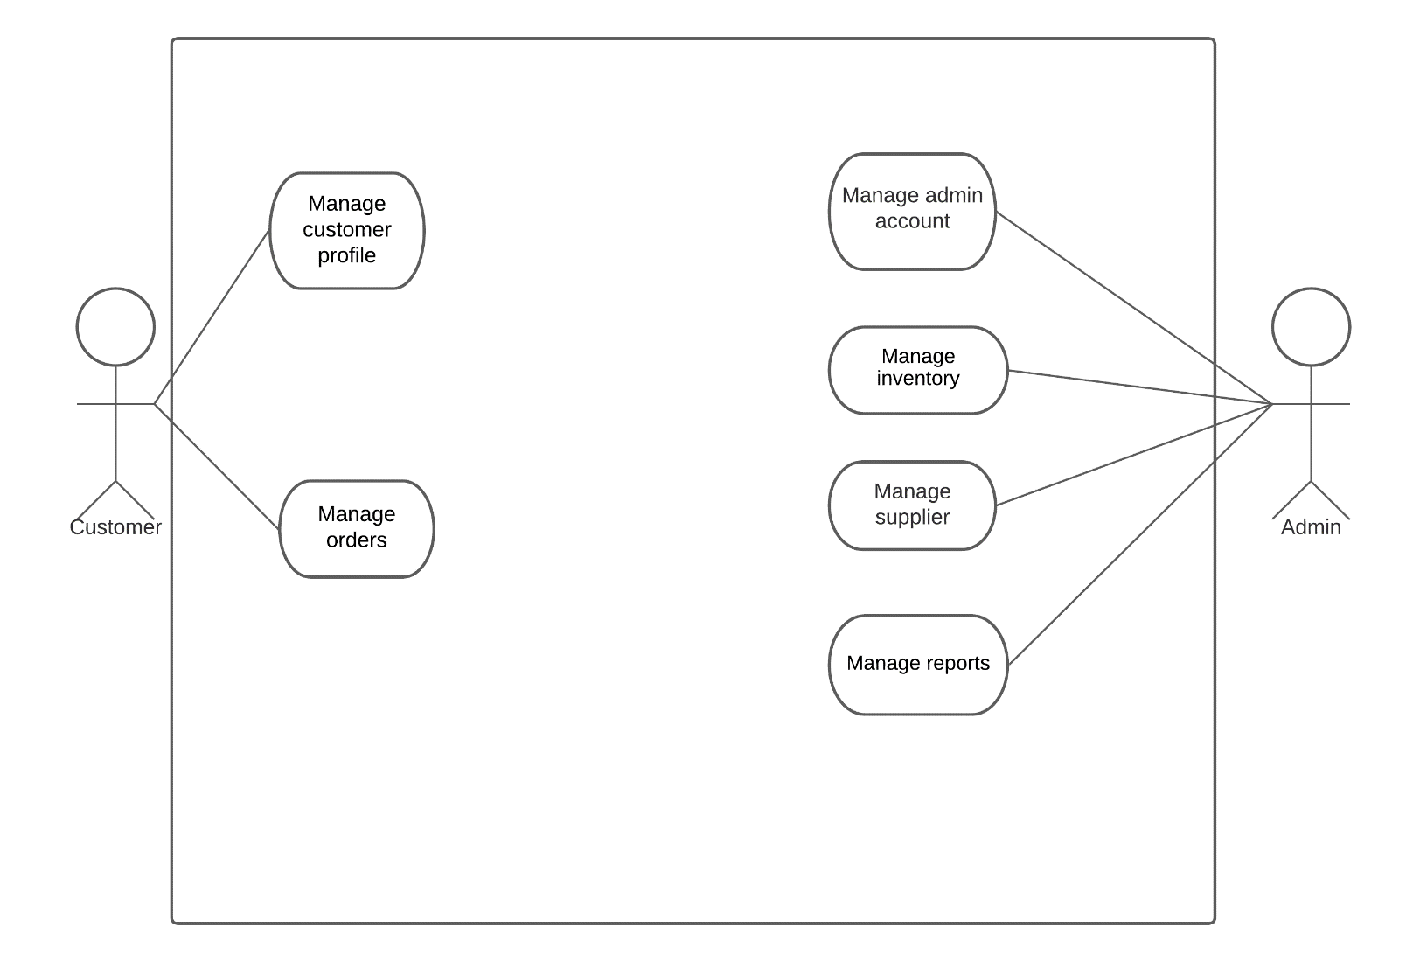

### Use Case Full Description

|  |  |  |
| --- | --- | --- |
| **Use Case Name:** | Manage Customer Profile | |
| **Scenario:** | Customer wants to edit information in their Profile | |
| **Triggering Event:** | User clicks on the Manage Account button. | |
| **Brief Description:** | This use case allows the user to edit or manage the name, address, contact number, or password registered in their account. | |
| **Actors:** | Customer | |
| **Related Use Cases:** |  | |
| **Stakeholders:** | Customer, Admin | |
| **Preconditions:** | * Must be logged in to account. * Account must already exist | |
| **Postconditions:** | * Changes made to the user account should be applied | |
| **Flow of Activities:** | **Actor** | **System** |
| 1. Customer clicks on the **“Sign-up”** button 2. Customer fills in all the required information in the registration form 3. Customer clicks on the “**Register”** button 4. Customer clicks on the **“Manage Account”** button. 5. Customer edits/adds their information on their accounts. 6. Customer clicks on the **"Save"** button. 7. Customer closes the **“Manage Account”** screen | 1.1 System opens the registration page.  3.1 System saves the information entered and creates an account containing the information submitted by the customer.  4.1 System opens the **“Manage Account”** page.  6.1 System displays a pop-up message **“Are you sure you wish to save these changes?”**  7.1 System updates the account depending on the edits or adds information given by the user. |
| **Exception Conditions:** | 3.1 If the customer were to leave a required field empty, a pop-up message will appear notifying the customer to add information to the required field; The required fields are First Name, Last Name, Address, Contact Number, Password.  6.1 If the customer were to leave a required field empty, a pop-up message will appear notifying the customer to add information to the required field; The required fields are First Name, Last Name, Address, Contact Number, Password. |  |

|  |  |  |
| --- | --- | --- |
| **Use Case Name:** | Manage Order | |
| **Scenario:** | Customer wants to edit the items in their cart | |
| **Triggering Event:** | User clicks on the “shopping cart” icon to view their orders | |
| **Brief Description:** | This use case allows the user to add or delete the number of orders per item that are already in their cart. | |
| **Actors:** | Customer | |
| **Related Use Cases:** |  | |
| **Stakeholders:** | Admin | |
| **Preconditions:** | * Must have an existing account. * Must be logged in to account | |
| **Postconditions:** | * All changes to their shopping cart have been updated | |
| **Flow of Activities:** | **Actor** | **System** |
| 1. Customer clicks on the item to open the item’s page. 2. Customer adds a new item to their cart. 3. Customer clicks on the **“Shopping cart”** icon 4. Customer edits or removes an existing item. 5. Customer clicks on the "Save" button. 6. Customer selects the items they want to check out. 7. Customer presses the “**Check-out**” button. 8. Customer selects shipping method. 9. Customer checks the order details. 10. Customer clicks the “**Confirm Order**” button to finalize the order. 11. Customer views the **“Transaction History”** 12. Customer clicks the close button on the **“Transaction History”** page | 1.1 System opens the item page.  2.1 System adds the chosen item to the customer’s cart.  3.1 System opens the cart menu.  5.1 System validates all orders.  5.2 System submits orders to Admin side.    7.1 Updates the Cart Menu and the Transactions Menu based on the checked-out items.  7.2 System displays the order details.  10.1 System sends the finalized order to the admin side to process the transaction.  11.1 System opens the **“Transaction History”** page.  12.1 System closes the **“Transaction History”** page. |
| **Exception Conditions:** | 5.1 If items in the basket have gone out-of-stock, but still was not edited out the system will display an error message stating that the customer must remove the out-of-stock item in the cart.  7.1 If the item that was checked out is no longer in stock, the system will gray-out the “**check-out”** button making it unclickable | |
| **Alternate Flow** | 1. Customer clicks on the item to add to their cart. 2. Customer adds a new item to their cart. 3. Customer clicks on the **“Shopping cart”** icon 4. Customer edits or removes an existing item. 5. Customer clicks on the "Save" button. 6. Customer selects the items they want to check out. 7. Customer presses the “**Check-out**” button. 8. Customer selects shipping method. 9. Customer checks the order details. 10. Customer clicks the “**Confirm Order**” button to finalize the order. 11. Customer views the **“Transaction History”** 12. Customer clicks the close button on the **“Transaction History”** page. | |

|  |  |  |
| --- | --- | --- |
| **Use Case Name:** | Manage Inventory | |
| **Scenario:** | Admin wants to view Inventory.  Admin wants to add Inventory data.  Admin wants to edit existing Inventory data | |
| **Triggering Event:** | Admin clicks on the Manage Inventory button.  Low stock notification | |
| **Brief Description:** | This use case allows the admin to edit or manage the inventory | |
| **Actors:** | Admin | |
| **Related Use Cases:** | N/A | |
| **Stakeholders:** | n/a | |
| **Preconditions:** | * User account must have admin access. * Account must be logged in | |
| **Postconditions:** | * Updates and edits to the Inventory should be applied | |
| **Flow of Activities:** | **Actor** | **System** |
| 1. Admin clicks on the **“Manage Inventory”** button. 2. Admin adds to or edits one or more items in their Inventory. 3. Admin clicks on the "Save" button. 4. Admin closes the **“Manage Inventory”** screen. 5. Admin clicks on the **“Manage Displayed Items”** button. 6. Admin edits the system based on their current needs. 7. Admin clicks on the **"Save"** button. 8. Admin clicks on the **“Yes”** 9. Admin closes the **“Manage Displayed Items”** screen. | 1.1 System opens the **“Manage Inventory”** screen.  3.1 Updates their Inventory data based on the edits that the admin does.  5.1 System opens the “**Manage Displayed Items”** screen.  6.1 System displays a pop-up message **“Are you sure you wish to save these changes?”**  7.1 Updates the system based on the edits that the admin did. |
| **Exception Conditions:** | 3.1 If the item added already exists in the system, an error message stating that duplicate items are not allowed will be displayed. 7.1 If a specific item is already added into the “Featured Items” section admin can no longer add the same item. | |

|  |  |  |
| --- | --- | --- |
| **Use Case Name:** | Manage Report | |
| **Scenario:** | Admin wants to produce Report (specific time frame)  Admin wants to view Report (specific time frame) | |
| **Triggering Event:** | Admin clicks on Manage Report button | |
| **Brief Description:** | This use case allows the admin to edit or manage reports. The reports that can be generated are sales reports, and inventory reports. | |
| **Actors:** | Admin | |
| **Related Use Cases:** |  | |
| **Stakeholders:** | n/a | |
| **Preconditions:** | * User account must have admin access. * Account must be logged in. | |
| **Postconditions:** | * report of specified time frame must be generated | |
| **Flow of Activities:** | **Actor** | **System** |
| 1. Admin clicks on the **“Manage Report”** button. 2. Admin chooses the time frame that the report to be made will include. 3. Admin closes the **“Manage Report”** screen | 1.1 System opens the **“Manage Report”** screen.  2.1 Creates a report based on the admin's chosen time frame. |
| **Exception Conditions:** | 2.1 When the chosen time frame includes dates that are ahead of the present date, an error message will be displayed stating that there are chosen dates that have yet to pass.  2.1 There must be completed transactions in the system | |

|  |  |  |
| --- | --- | --- |
| **Use Case Name:** | Manage Suppliers | |
| **Scenario:** | Admin wants to view the supplier list.  Admin wants to edit supplier list.  Admin wants to add a supplier to the supplier list | |
| **Triggering Event:** | Admin clicks on Manage Supplier button | |
| **Brief Description:** | This use case allows the admin to add to, view, or edit the supplier list | |
| **Actors:** | Admin | |
| **Related Use Cases:** |  | |
| **Stakeholders:** | n/a | |
| **Preconditions:** | * User account must have admin access. * Account must be logged in. | |
| **Postconditions:** | * All changes made to the supplier list must be updated | |
| **Flow of Activities:** | **Actor** | **System** |
| 1. Admin clicks on the **“View Suppliers”** button. 2. Admin examines the list of suppliers. 3. Admin clicks on the **“Add/Edit Suppliers”** button. 4. Admin makes the necessary changes to the suppliers list. 5. Admin clicks on the **“Save”** button. 6. Admin clicks on the **“Yes”** button. 7. Admin closes the **"Suppliers Screen”** | 1.1 System opens the **“Supplier”** screen.  3.1 System makes the suppliers list editable.  5.1 System displays a pop-up message **“Are you sure you wish to save these changes?”**  6.1 System saves the changes made to the supplier.  6.2 System closes the **“Supplier”** screen. |
| **Exception Conditions:** | 5.1 If there is an existing supplier on the list that is the same to the “new” supplier added the system will prompt the user that having duplicate suppliers on the list is not allowed, thus not exiting the **“Supplier”** screen until the duplicate is removed. | |

|  |  |  |
| --- | --- | --- |
| **Use Case Name:** | Manage Admin Account | |
| **Scenario:** | Admin wants to edit information in their Profile.  Admin wants to add information in their Profile | |
| **Triggering Event:** | Admin clicks on the Manage Account button. | |
| **Brief Description:** | This use case allows the user to edit or manage the name, address, or contact number registered in their account. | |
| **Actors:** | Admin | |
| **Related Use Cases:** | Manage User Account | |
| **Stakeholders:** | N/A | |
| **Preconditions:** | * User Account must have Admin access. * Must be logged in to account. * Account must already exist | |
| **Postconditions:** | * Changes made to the user account should be applied | |
| **Flow of Activities:** | **Actor** | **System** |
| 1. Admin clicks on the **“Manage Account”** button. 2. Admin edits/adds their information on their accounts. 3. Admin clicks on the "Save" button. 4. Admin clicks on the **“Yes”** button. 5. Admin closes the **“Manage Account”** screen | 1.1 System opens the **“Manage Account”** page.  3.1 System displays a pop-up message **“Are you sure you wish to save these changes?”**  4.1 System updates the account depending on the edits or adds information given by the user. |
| **Exception Conditions:** | 3.1 If the Admin were to leave a required field empty, a pop-up message will appear notifying the customer to add information to the required field; The required fields are First Name, Last Name, Address, Contact Number, Password. | |

## Gap Analysis

|  |  |  |  |
| --- | --- | --- | --- |
| Product Backlog ID | Current System | Proposed Changes | Impact |
| 4 | Each time the customer orders, he/she must dictate the contact information in order to deliver it on the right address | The contact information of each customer will be stored in the database so that if he/she orders again, it has an automatic contact information | High |
| 10 | Manually checking/counting inventory every end of the day/shift | Each item has its own records of inventory made by the system and automatically deducted when customer bought the item | High |
| 12 | Manually checking on the receipts that has been made if it’s still pending or not yet prepared | The system can check the orders if it’s still pending or the deliver to the buyer/customer is successful | High |
| 17 | Manually counting the sales that has been made every end of the day | The system can count all successful transactions that has been made each day or overall sales | High |
| 18 | Manually printing sales report by clicking each transaction of the day | The system can generate sales report depending on what the admin/employees need (daily, weekly, monthly, and yearly) | Medium |
| 19 | Manually writing in the receipt form the orders of each customer | The system can generate receipts on what the customers ordered in the system | High |
| 22 | Asking admins/employees what available items are in the company | The customers can browse the website to see all items available and on stock | High |
| 24 | Using messenger as their primary platform for ordering items to the company | The customers can order through the website and can also edit by the admins if there are any changes | High |

## System Analysis and Design

### Context Diagram

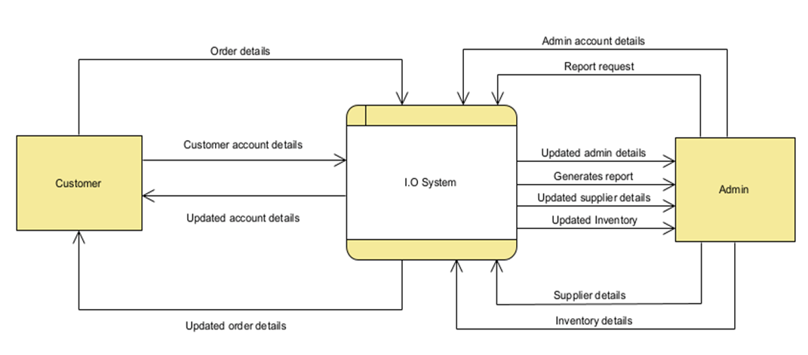

### Data Flow Diagrams

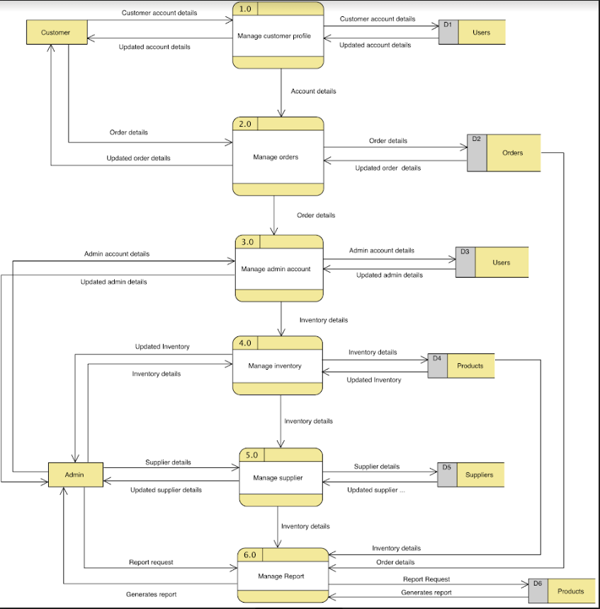

Data Flow Diagram (level 0)

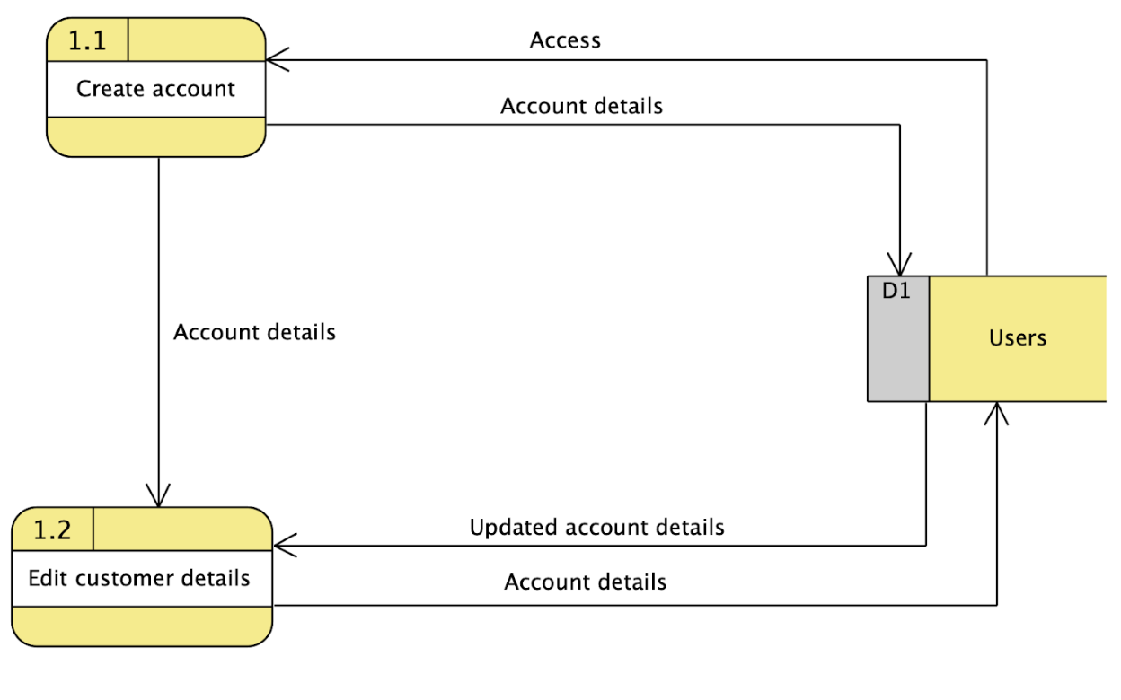

Data Flow Diagram Level 1 (Process 1)

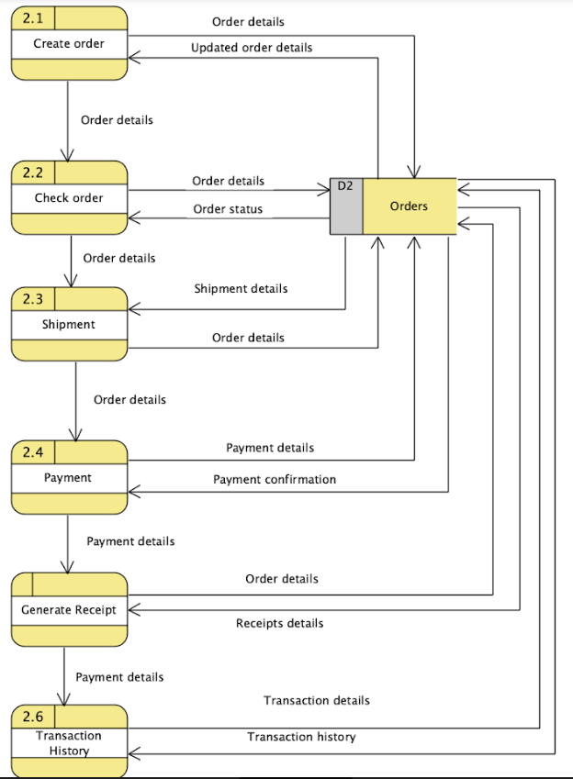

Data Flow Diagram Level 1 (Process 2)

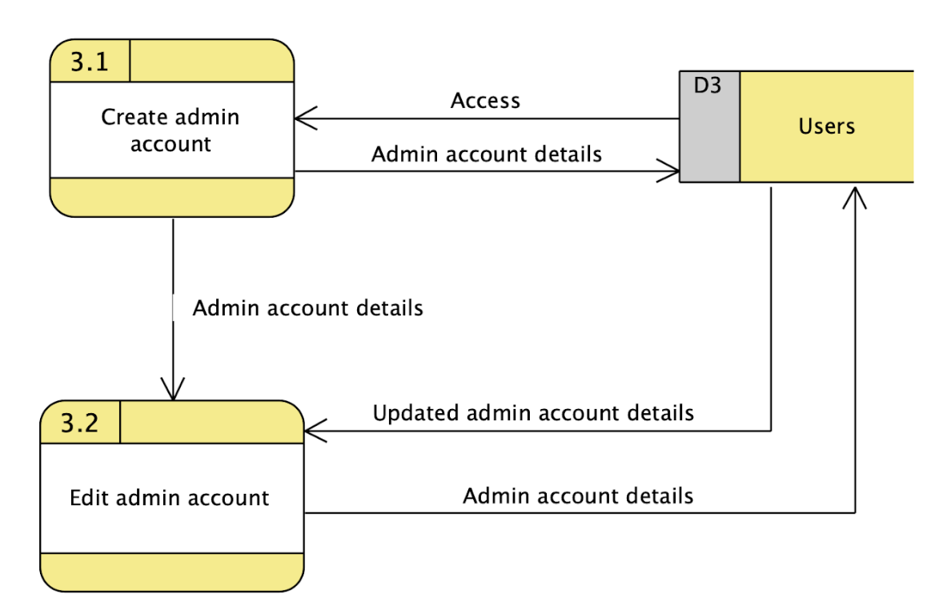

Data Flow Diagram Level 1 (Process 3)

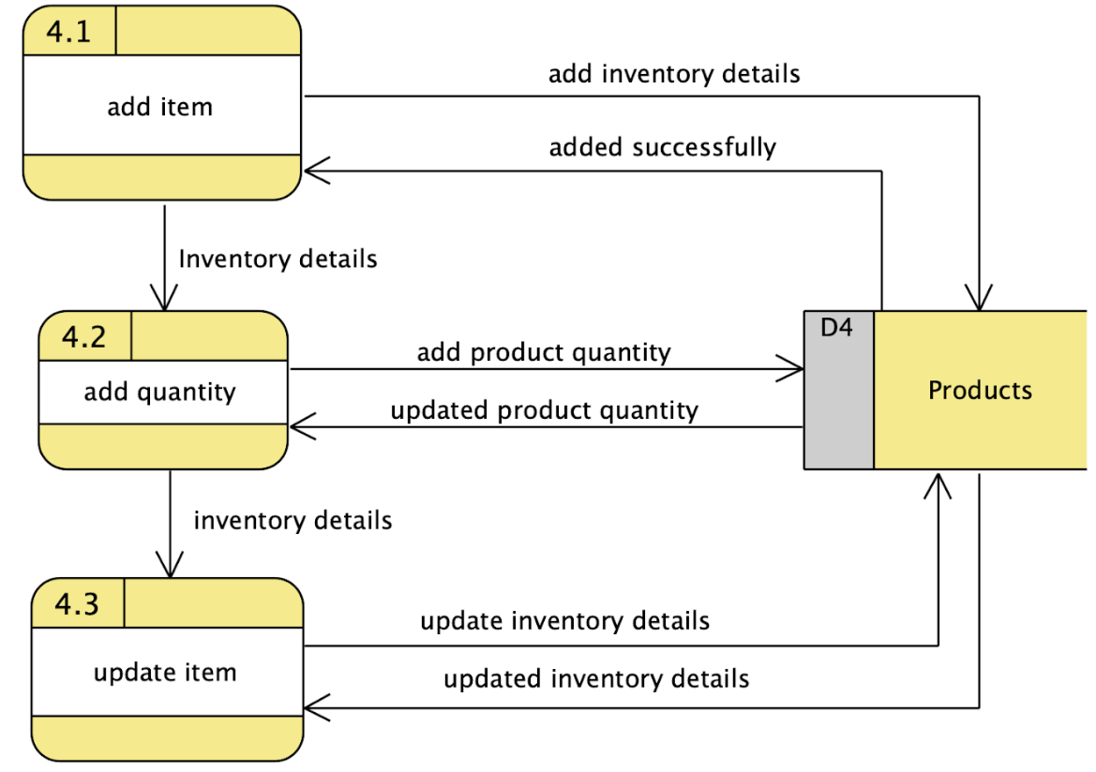

Data Flow Diagram Level 1 (Process 4)

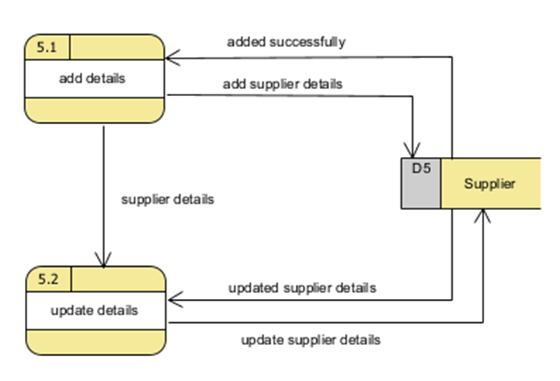

Data Flow Diagram Level 1 (Process 5)

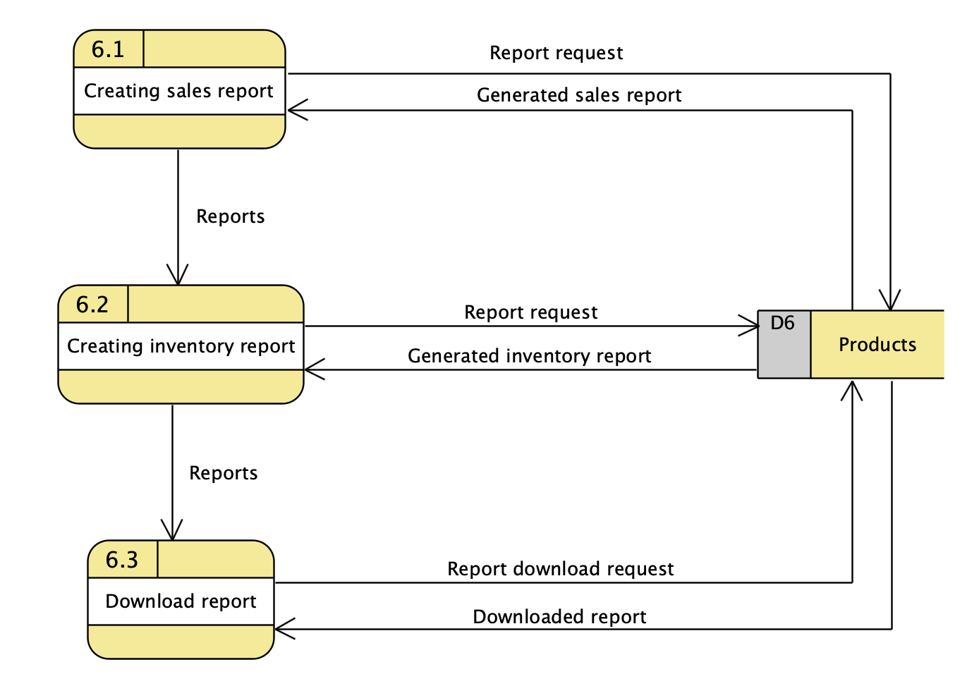

Data Flow Diagram Level 1 (Process 6)

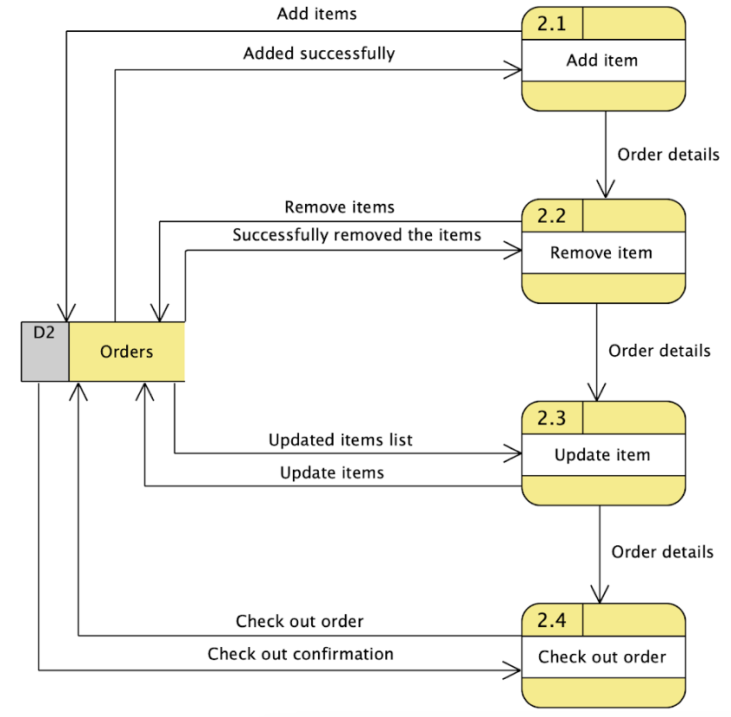

Data Flow Diagram Level 2 (Process 2)

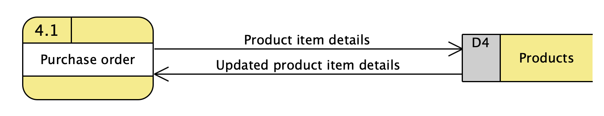

Data Flow Diagram Level 2 (Process 4)

### Entity-Relationship Diagrams

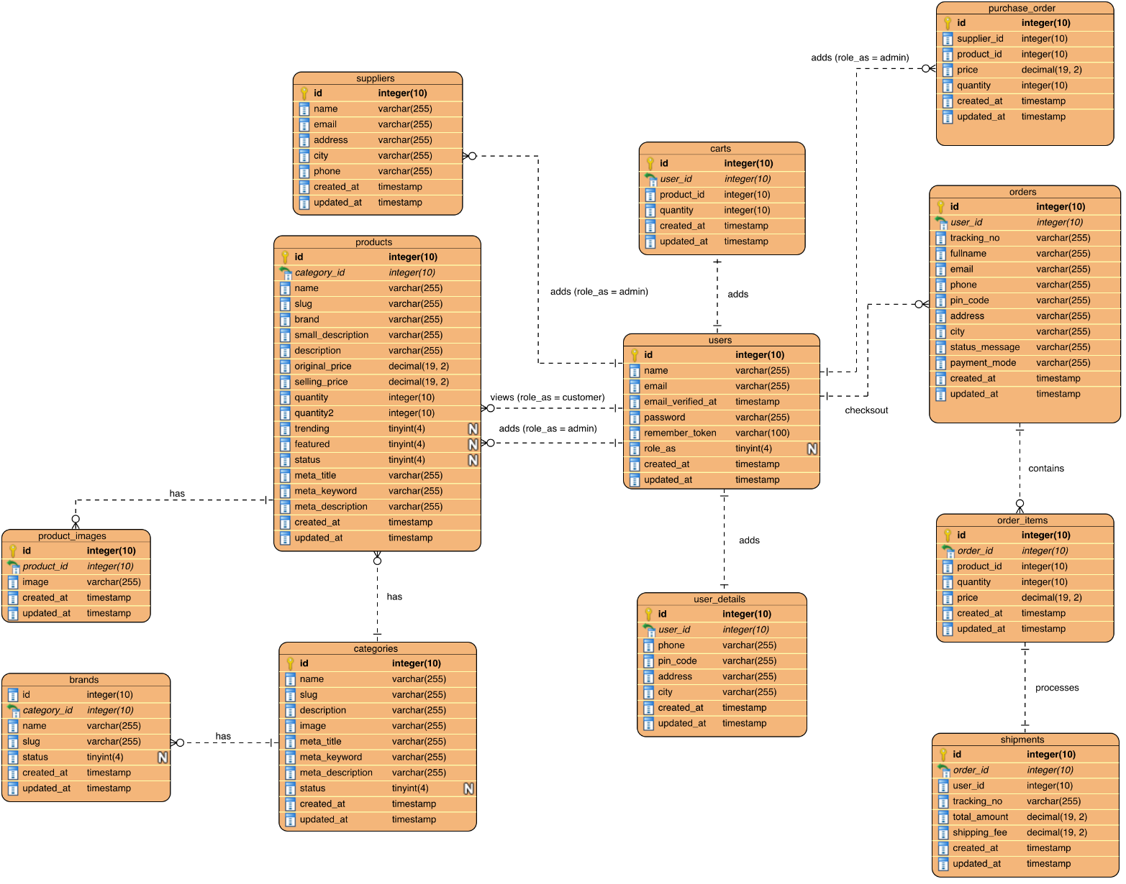

### Activity Diagrams

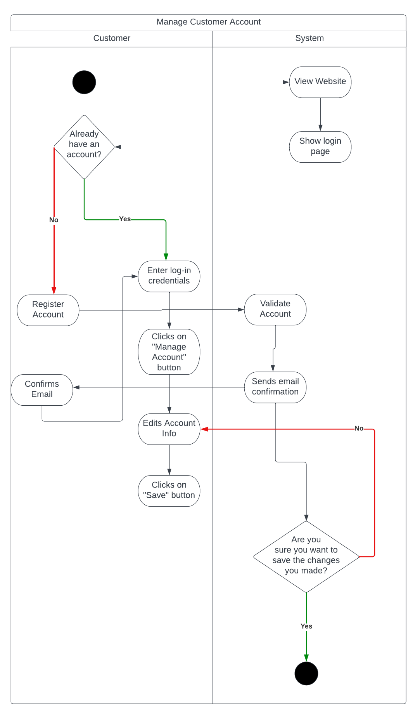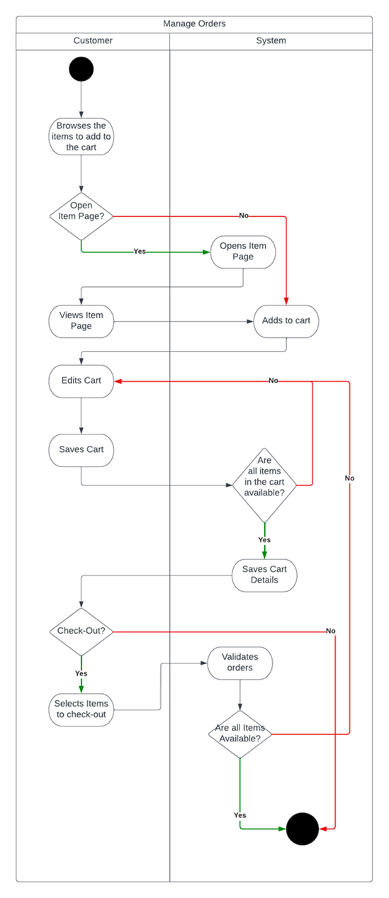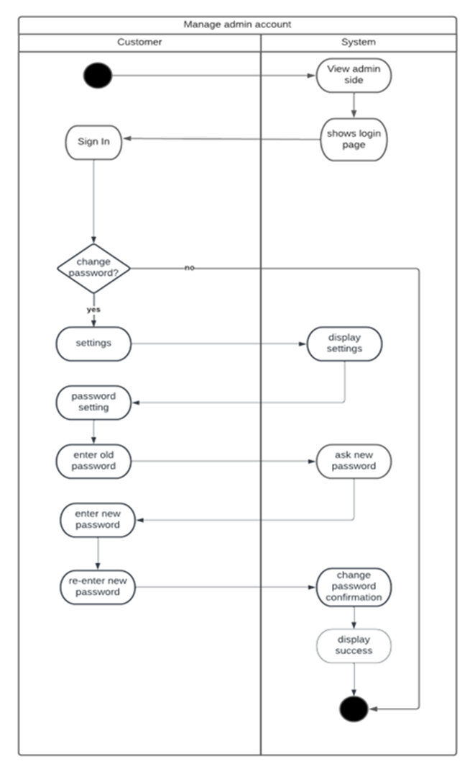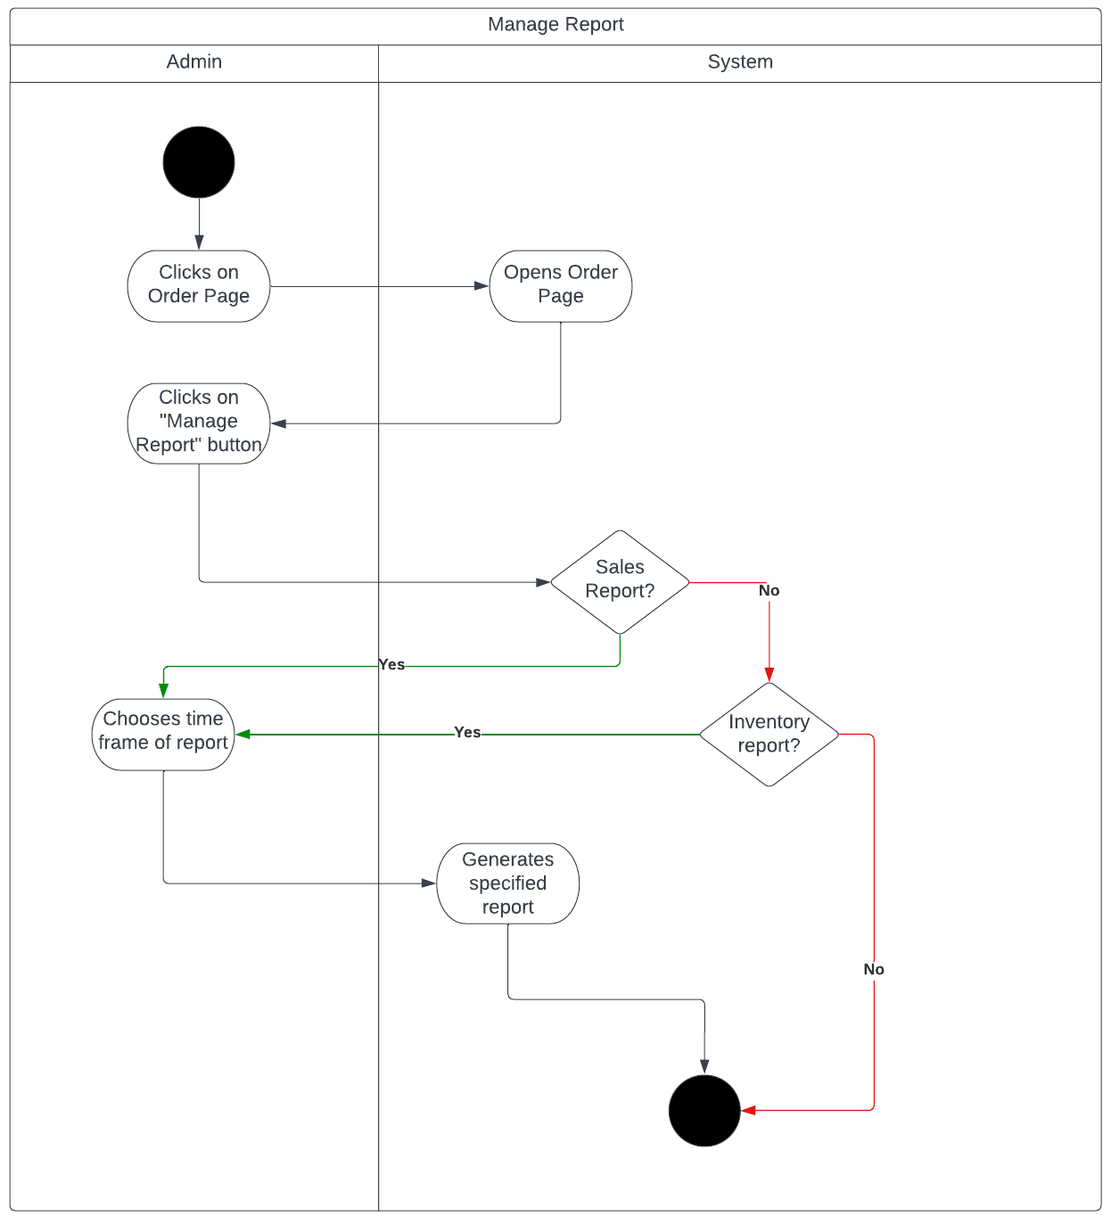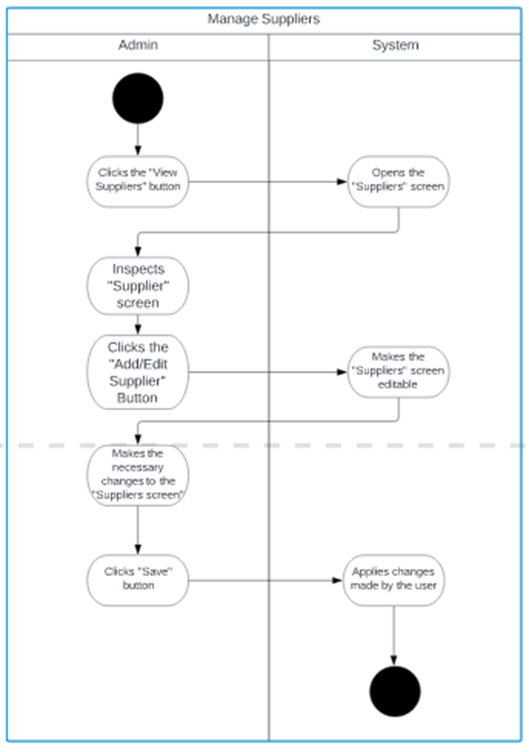

1. Object Diagrams

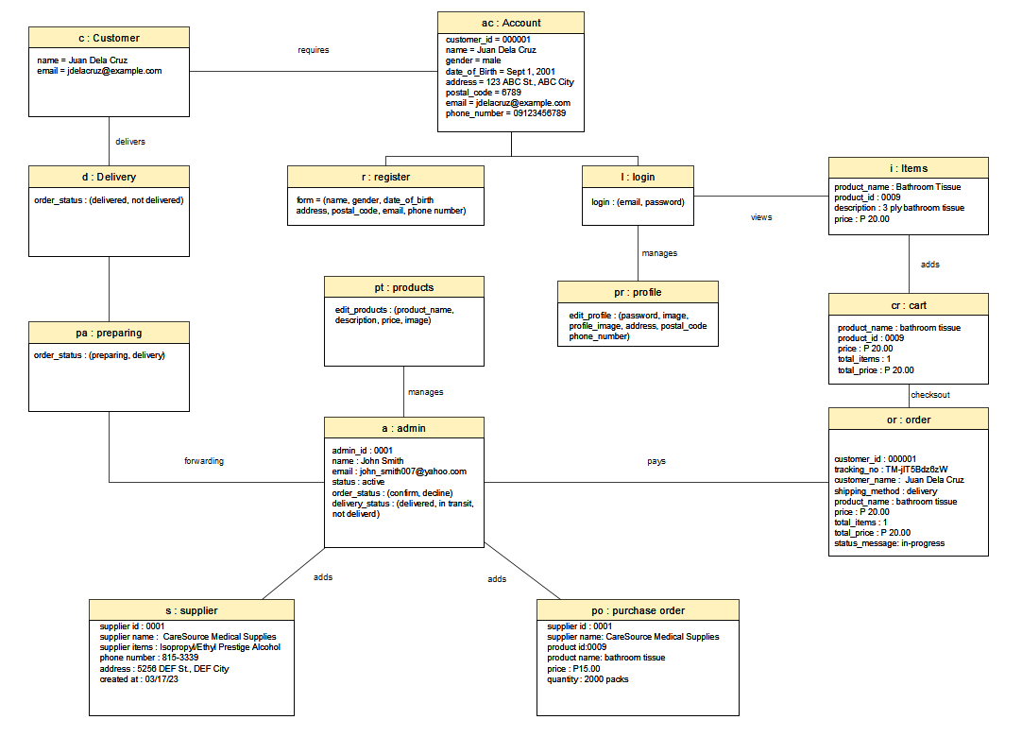

1. Class Diagrams

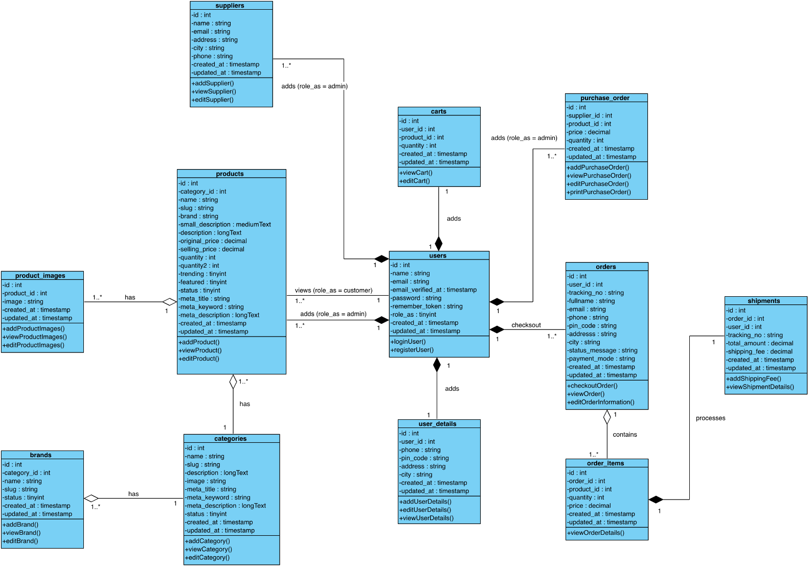

### Sequence Diagrams

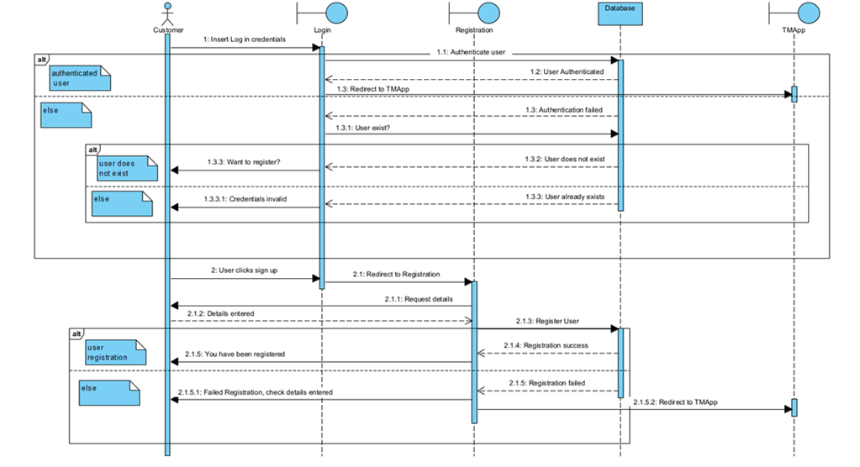

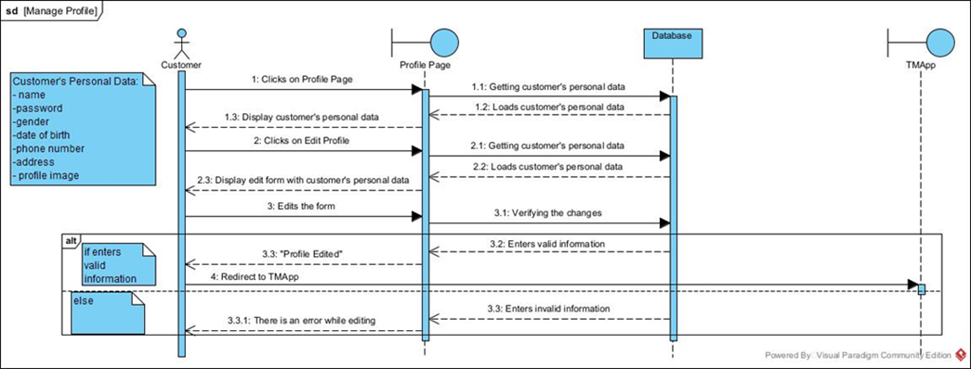

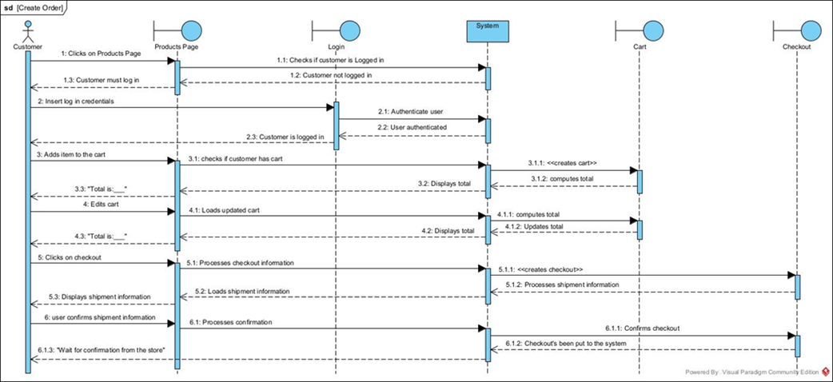

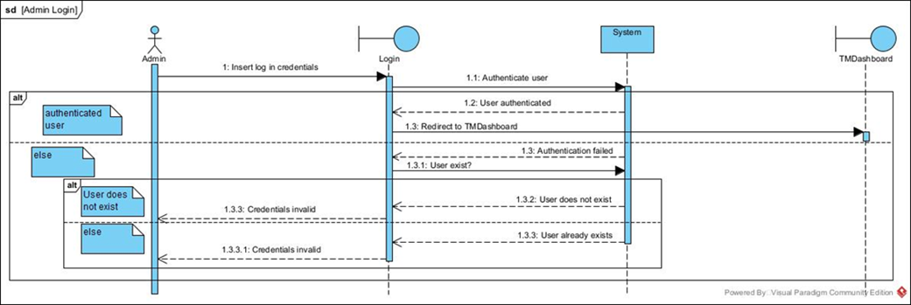

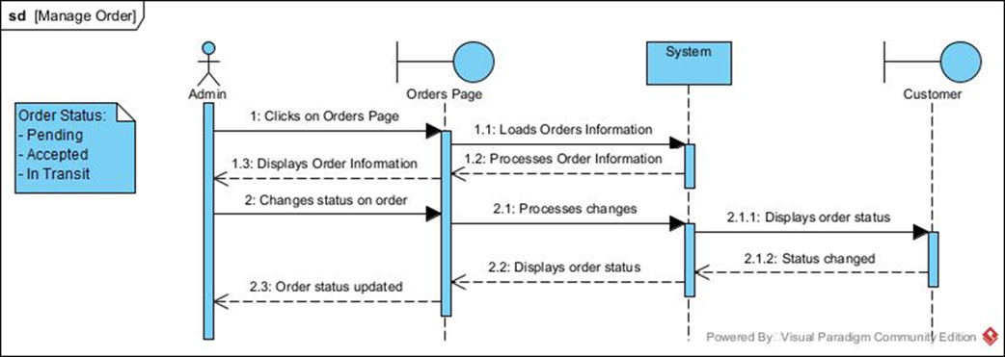

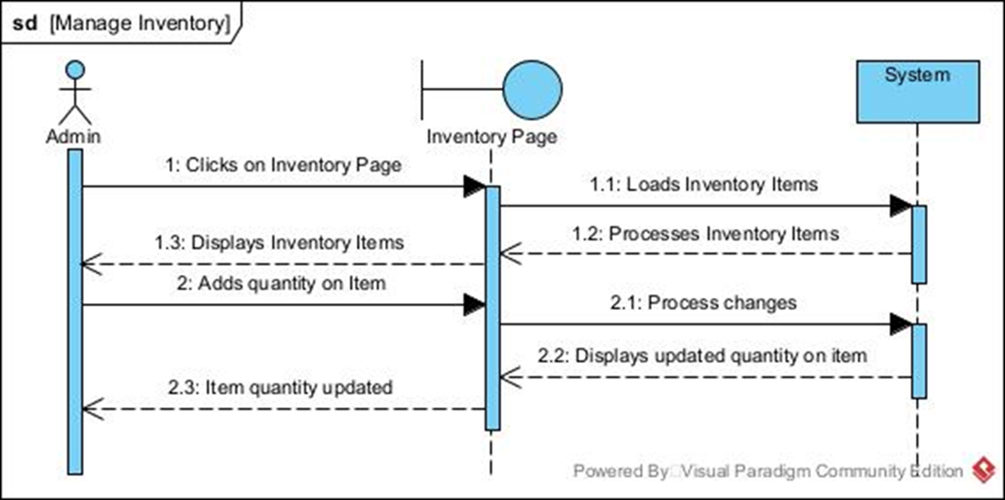

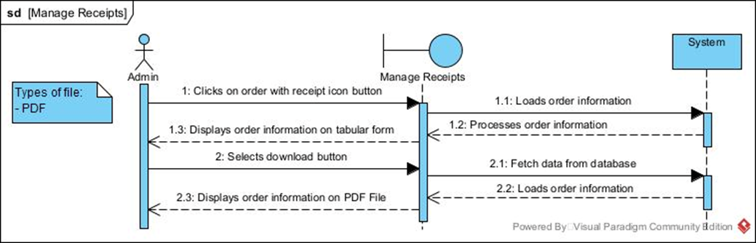

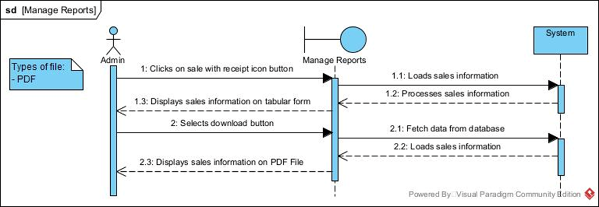

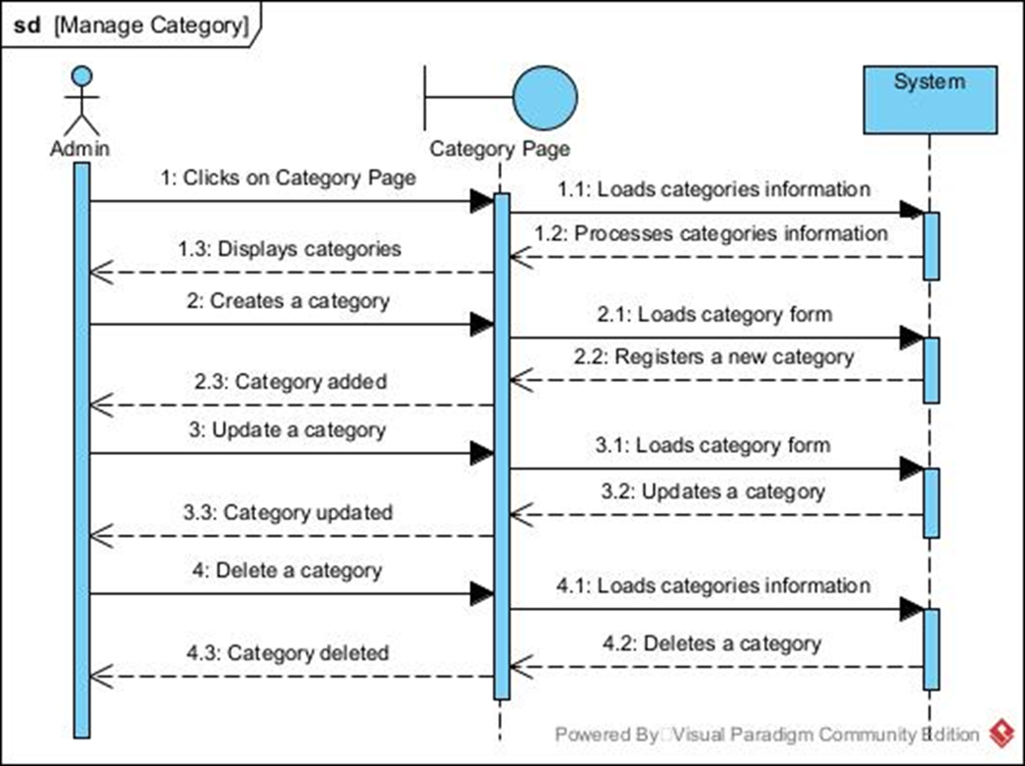

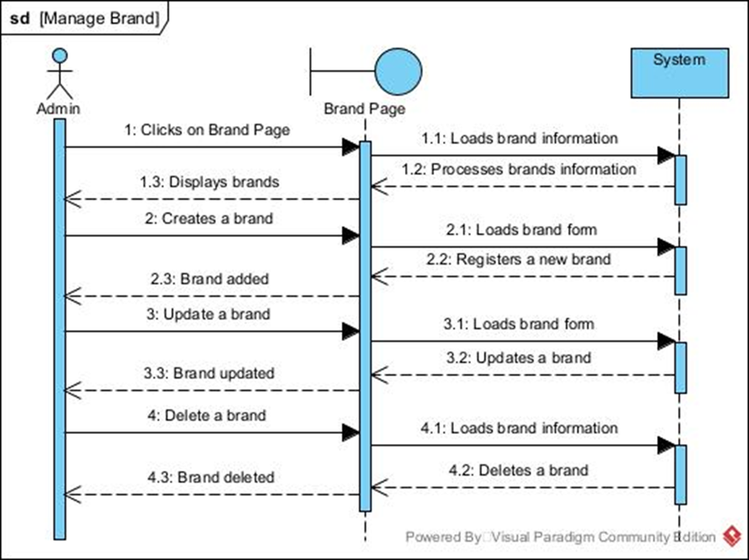

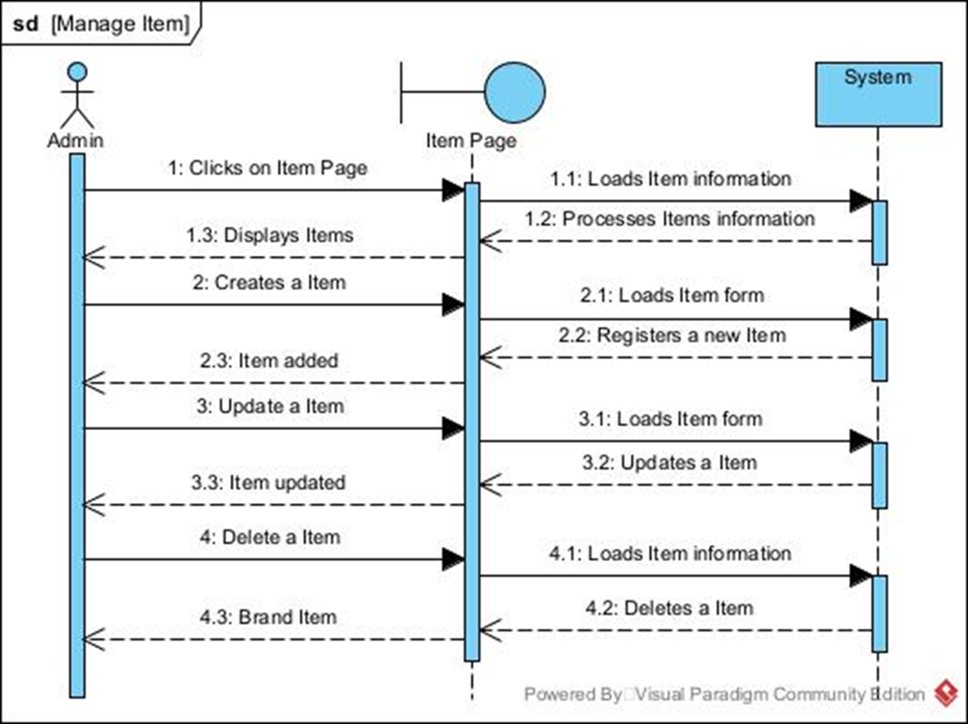

### Package Diagram

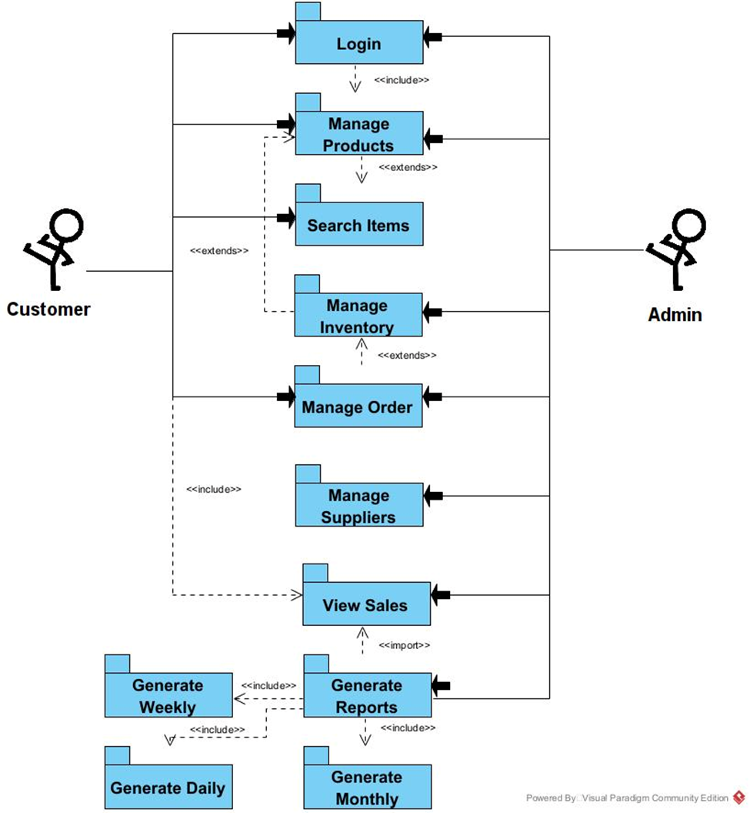

### Component Diagram

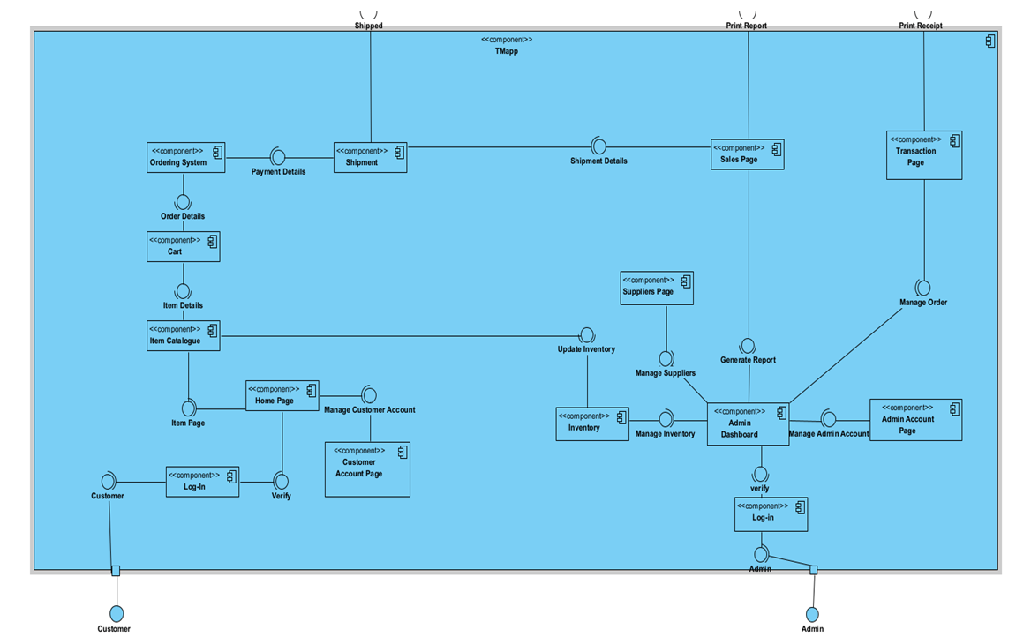

### Deployment Diagram

1. State Machine Diagram

# Results and Discussion

## 5.1 Release Plan

RELEASE 1

* Admin and Employees can login
* Admin can create, edit, and delete Employees and Customers
* Admin can create, edit, and delete Categories.
* Admin can create, edit, and delete Products.
* Admin can create, edit, and delete Suppliers.
* Admin can view Daily Sales
* Employees can edit Customers’ Accounts
* Employees can edit Products.

REALEASE 2

* Admin and Employees create, edit, view, and delete Transactions.
* Admin and Employees can browse through the main website.
* Admin and Employees can see all inputs on the main website.
* Customers can register and login on the main website.
* Customers can browse through the website.
* Customers can order and edit their orders on the main website.
* Customers can check their transaction history.

RELEASE 3

* Admin and Employees can edit information on their account.
* Admin and Employees can print receipts.
* Admin and Employees can generate and print reports (transactions and sales)
* Customers can edit their credentials/information on the website.
* Customers can download virtual receipt files even on their previous transactions.

## 5.2 Prototype

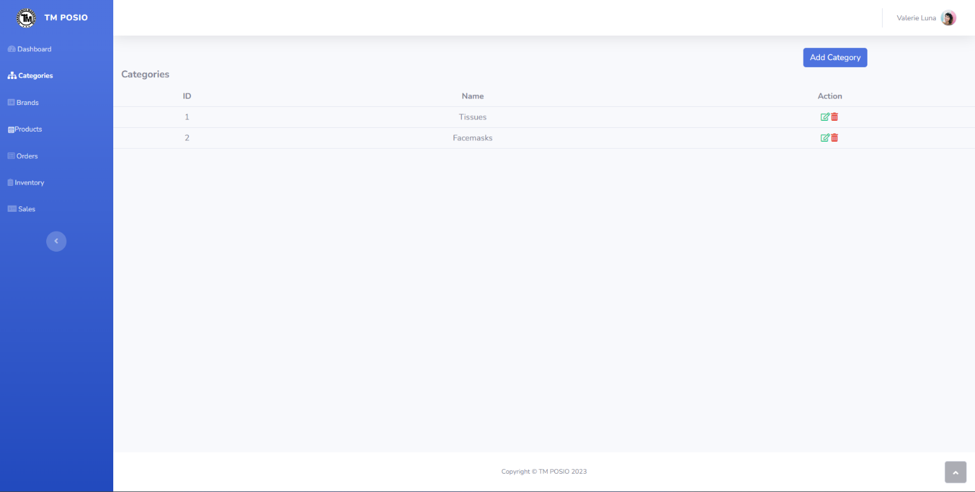

## 5.3 Use Classes and Characteristics

|  |  |
| --- | --- |
| *Roles* | *Description* |
| *Admin (Head)* | * This user portrays the most important role as he/she has the control over the website. * He/she assigns roles to different staff to help maintain and manage the website. * This user manages all other accounts on the website. |
| *Employee* | * This user will handle all inquiries and orders from the customers. * He/she can also monitor all transactions and sales of the company. |
| *Dev Team* | * This user oversees the maintenance of the software. * He/she will update the software if there are changes. |
| *Customer* | * This user can browse the main website. * He/she can order through the website. |

# Conclusion

The group has implemented the basics for an online inventory system for Torrecamps Marketing. This will allow the company to automate their inventory eliminating errors that can occur. The system will also be able to generate reports on sales and inventory. The group also created their client’s own personal web store where they can sell their wares. This will help customer find the products that they need and will help the company manage their client’s transactions.

For the future developments, there can be an inclusion of the use of APIs to connect the inventory system to other online markets such as the Facebook Marketplace, Messenger, Lazada, and Shopee will be helpful. The addition of different methods to pay online should also be added to the market app. The creation of the app for the IOS should also be considered to gain more market reach.

# References

|  |  |
| --- | --- |
| [1] | B. LI, "Goal 12—Ensuring Sustainable Consumption and Production Patterns: An Essential Requirement for Sustainable Development," United Nation, April 2015. [Online]. Available: <https://www.un.org/en/chronicle/article/goal-12-ensuring-sustainable-consumption-and-production-patterns-essential-requirement-sustainable>. [Accessed 1 November 2022]. |
| [2] | F. R. I. I. R. Angelica, "The Web-Based Internet Cafe (RIC) Raharja Ordering System," Raharja Internet Cafe, 28 March 2019. [Online]. Available: <https://att.aptisi.or.id/index.php/att/article/view/30>. [Accessed 28 October 2022]. |
| [3] | Manila Bulletin, "Shopee continues push to make e-commerce for everyone," Manila Bulletin, 20 March 2022. [Online]. Available: <https://mb.com.ph/2022/03/20/shopee-continues-push-to-make-e-commerce-for-everyone-2/>. [Accessed 29 October 2022]. |
| [4] | Shopee, "Payment Options," Shopee, 17 December 2018. [Online]. Available: [https://help.shopee.ph/portal/article/81131-[New-to-Shopee]-What-payment-options-does-Shopee-support%3F](https://help.shopee.ph/portal/article/81131-%5bNew-to-Shopee%5d-What-payment-options-does-Shopee-support). [Accessed 29 October 2022]. |
| [5] | Lazada, "About," Lazada, 2022. [Online]. Available: <https://group.lazada.com/en/about/?spm=a2o4l.searchlist.footer_top.9.533d6a9fTpf2SL>. [Accessed 29 October 2022]. |
| [6] | Cin7 Orderhive, "Lazada Inventory Management," Lazada, 2022. [Online]. Available: <https://www.orderhive.com/lazada.html>. [Accessed 29 October 2022]. |
| [7] | Pinoy Negosyo, "107 Online Shopping Sites in the Philippines," Pinoy Negosyo, 22 November 2018. [Online]. Available: <https://pinoynegosyo.net/business/online-shopping-philippines-906.html>. [Accessed 1 November 2022]. |
| [8] | Carousell, "OLX is now Carousell," Carousell, 2019. [Online]. Available: <https://blog.carousell.ph/about-carousell-philippines/olx-now-carousell/>. [Accessed 1 November 2022]. |
| [9] | Carousell, "Carousell Features," Carousell, 2019. [Online]. Available: <https://one.carousell.ph/easy-for-everyone/>. [Accessed 1 November 2022]. |
| [10] | Carousell, "Carousell Help Centre," Carousell, 2019. [Online]. Available: <https://support.carousell.com/hc/en-us/articles/115006305247-How-do-I-buy-on-Carousell->. [Accessed 1 November 2022]. |
| [11] | Metro Deal, "About Us," Metro Deal, 2022. [Online]. Available: <https://www.metrodeal.com/about-us>. [Accessed 1 November 2022]. |
| [12] | Pinoy Negosyo, "107 Online Shopping Sites in the Philippines," Pinoy Negosyo, 22 November 2018. [Online]. Available: <https://pinoynegosyo.net/business/online-shopping-philippines-906.html>. [Accessed 1 November 2022]. |
| [13] | Vouchers Poratal, "MetroDeal Discount Codes And Offers At Voucher Portal Philippines," Vouchers Poratal, 4 December 2020. [Online]. Available: <https://www.vouchersportal.com/ph/metrodeal>. [Accessed 1 November 2022]. |

# Appendices

## Appendix A: Project Vision

For Torrecamps Marketing who needs a system that could automate most of their transactional needs, the TM-Point of Sale System is an online transaction (ordering) and inventory system that can make sales, track their transactions, check their inventory, and generate reports. Unlike their current system which mainly focuses on manually doing their transactional needs such as using excel for their inventory and tracking their sales and orders, our product would automate these tasks and lessen the load on their workforce allowing them to do other tasks that the client would need.

For the customers of Torrecamps Marketing who do not have an ordering system to use. The TM Point of Sale System is an online transaction (ordering) and inventory system that can make sales, track their transactions, check their inventory, and generate reports. Unlike their current system, which is ordering through Facebook and Facebook Messenger, our product would allow the customers to have their own account for ordering items at Torrecamps Marketing.

## Appendix B: Schedule

## Appendix B: Feasibility

**Technical Feasibility**

In this section, the team will discuss the technical feasibility of the proposed solution. This will discuss all technical use and requirements needed to use the system.

The technical use of the system was discussed in the **Hardware** section. It was mentioned there that the browsers that the users will use have minimum requirements. To be able to access the website, they will need a laptop/desktop computer or a mobile smartphone, because the system is a web-based application.

The team will develop a web-based system with an ordering system that will help the customers and Torrecamps Marketing to accommodate more customers. The team proposed a POS with Inventory Management System that will help the admin and employees to keep track of their sales, inventory, and orders per customer. This will give them the ability to easily save every transaction and every move that they are making for their company. The team also proposed an Ordering System for the customers, this will help the customers to easily choose and order what they want to buy, this will also help them to keep track of what items they are buying. The Ordering System is also connected to the POS with Inventory Management System so that the orders of the customers will be added and recorded to the POS. They will also have the ability to download and print the receipts per customer and per order.

**Economic Feasibility**

In this section, the team will discuss the overall cost of Torrecamps Marketing to analyze where the cost should be needed.

Upon meeting with the client, the team will develop the system free of charge and it is also discussed in the capstone project that the development of this project will be free. The team will also be consistent with monitoring and updating if there are changes that need to be made. The team also discussed to the client that the team will not provide a free domain and they agree that they will pay for the domain to use the system that the team proposed when the panelists and the school approved the system and running smoothly.

The team will discuss the benefits of the proposed system:

1. A website that will help the customers browse all items.
2. A user-friendly POS and Inventory Management System that will minimize errors such as wrong orders, wrong addresses, wrong contact information, or any customer credentials.
3. The client can keep track of the stocks of their items and their daily sales.
4. This will attract a larger audience.
5. This will help the customers to minimize their inquiries because they can browse the items on the website.
6. This will help the admin and employees track their orders if ever they lose the receipt because the system has a feature that can print and/or download the receipts.

**Operational Feasibility**

In this section, the team will discuss the Operational Feasibility of the proposed system, how the system will run and what is the limitation of each user role. This will help the client understand how the system works.

The team will develop a POS and Inventory Management System with an Ordering System for the customers. This project will help improve the client’s needs and minimize the everyday problem of Torrecamps Marketing. This project has all the features that Torrecamps Marketing needs. This includes ordering, tracking of transactions, tracking of sales, tracking of stocks, and saving user credentials. Only the admin can create and delete user credentials and purchasable items, while the employees can only view and edit the user credentials and purchasable items. The user can only order, view their history, and browse all items displayed by the admin. These roles will help them segregate what they should be doing while using the system. This project will also help the customers in terms of choosing the right items that they want to buy. The team will still enhance the system when the client needs to change or add some features of the system.

**Schedule Feasibility**

In this section, the team will discuss the Schedule Feasibility of the proposed system in terms of time. This will help the team to manage the operation of the proposed solution within the span of time that the school will be given.

The capstone project is within the 3 terms, including this term which is 1st Term 2022-2023. If the proposed system is approved by the panelists and the school, the team will focus on system diagrams and system analysis next term 2nd Term 2022-2023. Then lastly, the 3rd and last term of the capstone project in AY 2022-2023, will be the completion and implementation of the proposed system that the team will develop.

The team will discuss and ensure that each member of the team will have a specific role and responsibilities for these whole 3 terms of the capstone project. This will help each member to contribute and learn how the capstone project works. The team has initially discussed the role and responsibilities of each member so that the limited period of this capstone project will be met.

## Appendix C: Product Roadmap

## Appendix D: Users’ Manual

## Appendix E: Team Meetings

## Appendix F: Source Code